Researcher Profile: Stephanie Bernard

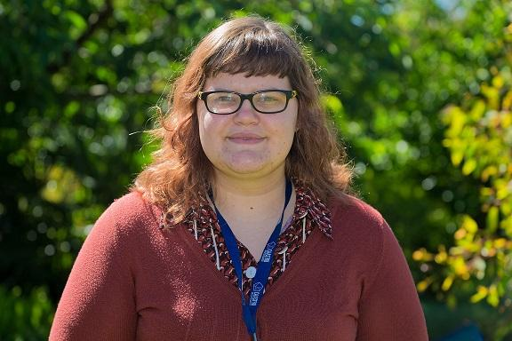
Fast Facts
Name
Stephanie Barnard

Job title
PhD Student, University of Melbourne

Where did you go to primary school and secondary school?
I grew up in Newcastle, New South Wales, just north of Sydney. I moved to Melbourne at the beginning of year 10 and finished high school in Werribee.

When you were a child, what did you want to be when you grew up?
Since I was about 7, I wanted to be an astronomer! I had a picture book on the planets in second grade that completely memorised me, and I moved on to exhausting the local library's books on astronomy and space in primary school. Since I worked in a pharmacy in high school, I also considered becoming a doctor or pharmacist, but ultimately decided on physics.

Where have you studied since finishing school?
I did my undergraduate studies at the University of Melbourne, where I studied physics and Russian language. I stayed at the University of Melbourne for my Masters degree in physics and for my PhD. During my Masters, I was externally supervised at Swinburne University of Technology, so I also did a lot of work with a group there.

Where have you worked?
During my time as an undergraduate, I volunteered for various groups in science communication, such as the In2Science program, where I helped science teachers in schools by doing demonstrations and experiments with students. I then moved on to work with the Telescopes in Schools program in Melbourne. I also worked at Swinburne University of Technology and the Australian National University as a summer research student. I'm currently a demonstrator in the School of Physics at the University of Melbourne, where I teach physics undergraduates to analyse astronomical images and simulate astronomical events, such as a black hole destroying the Solar system.

Describe your research in 150 characters or less.
I’m looking for the most distant galaxies in the Universe. We can currently see them to 500 million years after the Big Bang - 13.2 billion years ago!

What is the best part of your job?
The best part of my job is to tackle a problem and wrestle with it until I come to the solution. While it can be frustrating in the moment, it's always exciting to find a new result!

Name one impressive instrument that you’ve used for your research.
The data that I'm using for my PhD was taken with the Hubble Space Telescope, which was used to take images of the most distant galaxies in the Universe. Personally, the most impressive telescope I have used is the twin 10m Keck telescopes on Mauna Kea, Hawaii. We used this telescope to observe distant supernovae and find the properties of the galaxies that they come from.

What skills are essential to your job?
Computing skills are absolutely essential to my work - every day I do some form of computer programming. I'm also lucky enough to travel a lot and talk about my research, so being comfortable speaking in public and communicating is very important.

What advice would you give a school student who wants to become a scientist?
On a general level, I would say to go for it! Studying science is very challenging but extremely worthwhile, even if you don't continue onto postgraduate study. More specifically, learning as much maths and programming as possible will help you a lot. There are even loads of free courses on the internet to build these skills!

What do you do for fun in your spare time?
I have a few creative hobbies - I love to knit and sew clothes, and I try to keep the past alive with a large collection of film cameras that I regularly experiment with.

Media/videos
‘Vatican Observatory: Galaxies, and students, from near and far’, 9 June 2014, Vatican Radio. Interview with Stephanie from 5:20 in the audio file.
http://www.news.va/en/news/vatican-observatory-galaxies-and-students-from-nea

‘Kids never too young to start science classes at Endeavour Hills early learning centre’, 4 May 2014, Brittany Shanahan, Berwick Leader
http://www.heraldsun.com.au/leader/south-east/kids-never-too-young-to-start-science-classes-at-endeavour-hills-early-learning-centre/story-fngnvmhm-1226903190611

Twitter handle
@astro_stephi

Personal website
https://stephibernard.wordpress.com

Research in detail
My PhD work is focussed on galaxies in the early Universe – 500 million years after the Big Bang. I’m part of the Brightest of Reionising Galaxies (BoRG) survey, which uses the Wide Field Camera 3 on the Hubble Space Telescope to find the very brightest galaxies at this early time. We want to know how many of these galaxies there are, and to learn about their properties – for example, how big they are, and what kind of stars they contain.

For my Master of Science research, I looked at supernovae that occur from the most massive stars. These stars explode in extremely bright events called ‘superluminous’ supernovae. Since they are so bright, it’s possible that they could outshine their entire galaxies. I’m also interested in supernovae that occur on the outskirts of galaxies or otherwise very far away from a host galaxy. These supernovae are called ‘hostless’ or ‘orphan’ supernovae. I use the Dark Energy Camera (DECam) for Superluminous Supernovae to look for these events, and collaborate with the Australian Dark Energy Survey (OzDES) to take observations of their neighbouring galaxies.

I’m also involved with the Deeper, Wider, Faster survey, which uses the DECam to look for optical and ultraviolet radiation that could correspond with fast radio bursts. Fast radio bursts are extremely fast bursts of radio frequency radiation that last only milliseconds. Astrophysicists are yet to discover what causes fast radio bursts.

Images
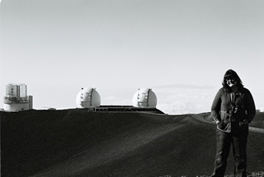
Stephanie Bernard at the summit of Mauna Kea, Hawaii, showing the twin 10m Keck telescope, December 2012

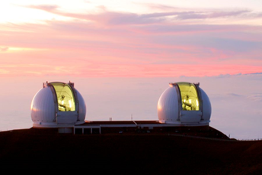
Twin 10m Keck telescopes on Mauna Kea, Hawaii
Image credit: SiOwl (Own work) [CC BY 3.0 (http://creativecommons.org/licenses/by/3.0)], via Wikimedia Commons

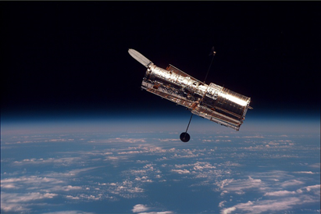
Hubble Space Telescope
Image credit: NASA - http://antwrp.gsfc.nasa.gov/apod/ap021124.htmlhttp://spaceflight.nasa.gov/gallery/images/shuttle/sts-82/html/s82e5937.html, Public Domain, https://commons.wikimedia.org/w/index.php?curid=118762

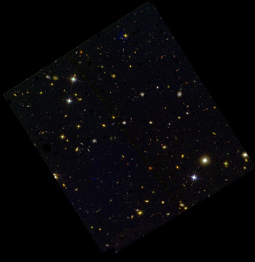
A Hubble Space Telescope image from the BoRG survey. I basically ignore all of the beautiful stars and galaxies that you can see in this image, and look instead at the very faint, red objects, which could be some of the earliest galaxies to have formed in the Universe.
Image credit: HST/BoRG team http://borg.physics.ucsb.edu/wp-content/uploads/2015/04/BoRGz9_1.jpg

