Researcher Profile Activities

Profiles of real CAASTRO researchers can be found here: http://www.caastro.org/researcher-profiles

The following classroom activities have been designed to provide students with engaging ways of exploring the researcher profiles. They aim to develop an appreciation for the day to day lives and the skills of scientists working in Australia and to inform students of current astrophysics research.

These activities link to the Science as a Human Endeavour strand of the Australian Curriculum Science as well as content from Earth and space sciences in the Science Understanding strand.

Why not share your work with the world? Please send finished work such as posters and business cards to citc@caastro.org.au and we will add examples of students’ work to the CAASTRO in the Classroom website.

List of Projects and Activities

List of Activities
Project 1 - Scientific Conference
Project 2 - Science Magazine
Activity 1 - Bio Poems
Activity 2 - Kennings Poem
Activity 3 - Business Card
Activity 4 - Scientific Poster
Activity 5 - Socialise with other scientists
Activity 6 - Fight for Funding
Activity 7 - Magazine Cover
Activity 8 - Magazine Article
Activity 9 - Cartoon Strip / Animation
Activity 10 - Job advertisement
Activity 11 - This is your life interview

Project 1 - Scientific Conference
Scientists often have to attend scientific conferences to share their discoveries, increase their professional profile and network with other scientists working in the same field. At these conferences, scientists often: hand out business cards to other scientists; prepare research posters to present their findings in an interesting and easy-to-read manner; and socialise with other academics to gain an insight into other people’s work. After meeting other researchers at a conference, scientists may form collaborations with researchers from different organisations or, alternatively, they may have to compete with them for future research funding.

This activity is best completed as a group activity, with each group of students given a profile for one researcher.

Group roles:
Students 1 & 2 - Create a business card (Activity 3)
Students 3 & 4 - Create a science poster (Activity 4)
Student 5 - Team leader. Oversee the work of the group and check that all information is correct and requirements are met.

Once your group has completed the business card and science poster, have Students 1 & 2 walk around to each of the other groups and find out what each of the scientists is studying and then report back to your group (Activity 5).

Using the information about your researcher, and information about the researchers from other groups, prepare a presentation to argue for research funding for your researcher (Activity 6).

Project 2 - Science Magazine
Science magazines are intended to keep the general public up to date with current research and scientific discoveries. These magazines often convey complex scientific ideas in an easy-to-read language, alongside eye-catching images.

Scenario:
CAASTRO has been given some grant funding to create a scientific magazine. You have been commissioned to design the magazine. Included in your submission will be a magazine cover, magazine article, cartoon strip and a job advertisement.

This activity can be done as either an individual or group project. Students will create their own scientific magazine including a:
- magazine cover (Activity 7)
- magazine article (Activity 8)
- cartoon strip (Activity 9) and,
- job advertisement (Activity 10)

Activity 1 - Bio Poems
Bio-poems are quick, fun writing activities for students. Here students can create a bio-poem as a way of exploring researcher profiles.

Instructions:
- Read the researcher profile that your teacher has given you.
- If there are any words you do not understand, check their meanings in a dictionary, on the internet, or ask your teacher.
- Construct a bio-poem for your researcher following the bio-poem format below.
- Once you have finished, draw a few pictures or insert some appropriate images into your poem.

Bio-poem format:
Line 1 – [Researcher’s name]
Line 2 – [Researcher’s occupation]
Line 2 – Who works at [University or company where your researcher works/studies]
Line 3 – Who grew up in [Where your researcher went to primary school and high school (if available)]
Line 4 – Who studied at [University(ies) that your researcher studied at]
Line 5 – Who can [Write something important your researcher does in this occupation]
Line 6 – Who knows how to [Write skills or knowledge necessary for this occupation]
Line 7 – Who uses [Technology that your researcher uses]
Line 8 – Who enjoys [Something your researcher likes doing]

Example:

Tara Murphy
An associate professor
Who works at the University of Sydney
Who grew up in Sydney
Who studied at the University of Edinburgh
Who can investigate astronomical objects that change rapidly
Who knows how to apply data mining to solve problems
Who uses the ASKAP radio telescope
Who enjoys riding her yellow bicycle

Activity 2 - Kennings Poem
A kenning is a two-word phrase that describes something or someone. Examples of a kenning include: “book reader”, “attention seeker” and “artistic painter”. A kennings poem is a poem with several lines of two-word phrases known as kennings. This is a great activity for enhancing literacy skills.

Instructions:
- Choose a researcher and write their name for the title.
- Using the information from the researcher profile, make a list of kennings (at least ten) - do NOT use the same words twice and make sure the second word in each kenning ends with “-er” or “-or”.
- Write each kenning on one line in the order of preference.

Example:

Tara Murphy
☙ ❧
Radio astronomer
Data analyser
Computer programmer
Enthusiastic educator
Supportive supervisor
Clear communicator
Logical thinker
Inspiring leader
Early achiever
Bicycle rider

Activity 3 - Business Card
This activity can be used as a part of a bigger project for a Scientific Conference.

Here you will create a business card that you can hand out to other researchers and potential investors at a Scientific Conference. Business cards are professional, informative and attractive and include all relevant information about a person so that you may contact them in future.

Instructions:
A business card must contain:
- First and last name
- Title (e.g. Dr, Prof., PhD)
- Job title (e.g. Astrophysicist, Astroseismologist, Cosmologist)
- Work address
- Phone number (make it up)
- Work email (make it up)
- Website link (if the researcher doesn’t have one, use www.caastro.org.au)
- Company logo (either make one up or use the CAASTRO logo here:
(http://www.caastro.org/uploads/caastro/files/CAASTRO-logo.png )

Resources:
You can create free business cards using the following website:
www.canva.com/create/business-cards

Example:
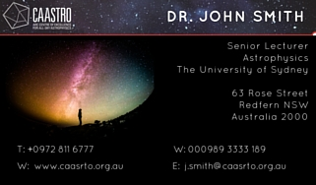

Activity 4 - Scientific Poster
This activity can be used as a part of a bigger project for a Scientific Conference.

Here you will create a poster for your researcher. Scientific posters are a visual summary. They are designed to be easily read, describe a “short story” of the research, arouse the reader's interest to read on and include eye-catching images of their work.

Your scientific poster may:
- provide a summary of your researcher’s work;
- convey some scientific information that is key to their research; OR
- depict a typical day of your researcher.

Resources:
You may decide to use Microsoft PowerPoint, Publisher or Word.
Or you can create free posters using the website: www.canva.com/create/posters or www.canva.com/create/infographics

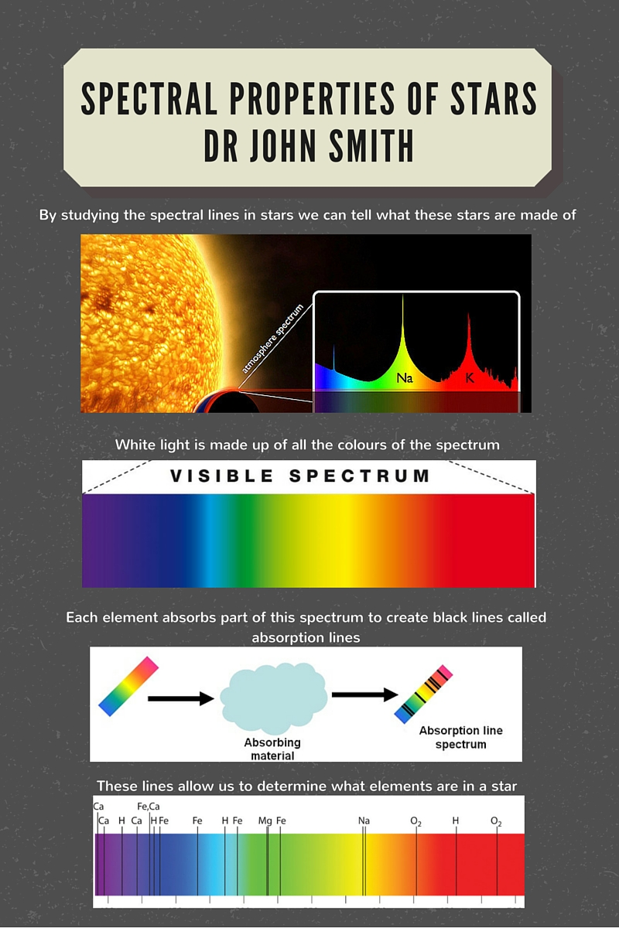
Example:

Activity 5 - Socialise with other scientists
This activity can be used as a part of a bigger project for a Scientific Conference.

One important skill that scientists require is the need to communicate well with other academics. This allows them to expand their knowledge of the scientific world, as well as make connections for future collaborations.

Here, your job is to walk around the room, study other scientist’s research posters and business cards, and discuss your work with other scientists.

While discussing ideas with other scientists, you may want to gather information about their research to help your team to win the “Fight for funding” activity.

Activity 6 - Fight for Funding
This activity can be used as a part of a bigger project for a Scientific Conference.

Scenario:
Your teacher has been given $100,000 by the Australian Government Department of Science, Information Technology and Innovation. This money is to be divided among local researchers with first place receiving a $60,000 grant, second place receiving a $30,000 grant, and third place receiving a $10,000 grant.

The allocation of money will be decided following formal presentations by competing scientists and their teams. Your team has to research and present a well structured argument outlining why you deserve a share in the money. After a brief presentation, teams will be asked questions from their teacher and other students about their research.

The first speaker will present your researcher to the class including:
- their name
- qualifications
- education history
- field of study
- their current research
- need for funding (how the funding will be used)

As a team, you will then be asked questions by your teacher or classmates about your scientist and their funding. Classmates will include other scientists applying for the grant funding.

After responding, the teacher will determine how the funding will be allocated.

Activity 7 - Magazine Cover
This activity can be used as a part of a bigger project for a Science Magazine.

Scenario:
CAASTRO has been given some grant funding to create a scientific magazine. You have been commissioned to design the magazine including its name, images and pricing.

Instructions:
- Come up with a name for the magazine. This should be catchy and relevant.
- Design a logo for the name.
- Use the name and logo, along with pictures from your researcher's field/topic to create a magazine cover.

Resources:
You may decide to use Microsoft PowerPoint, Publisher or Word to create your magazine cover.
Or you can create free magazine covers posters using the website: www.canva.com/create/magazine-covers

Examples:

www.australasianscience.com.au

https://cosmosmagazine.com
www.nationalgeographic.com/au

Activity 8 - Magazine Article
This activity can be used as a part of a bigger project for a Science Magazine.

Scenario:
You have been asked to write a magazine article for COSMOS, an Australian science magazine, based on the recent scientific discoveries of an Australian scientist working for CAASTRO. Below is a list of instructions given to you by the newspaper editor.

Instructions:
- Read the researcher profile that your teacher has given you.
- If there are any words you do not understand, check their meanings in a dictionary, on the internet, or ask your teacher.
- Write a magazine article, making sure to include:
  - The name and occupation of your scientist
  - A summary of his or her childhood/upbringing
  - An outline of his or her research
  - One or two images relevant to his or her research
- Your teacher may either ask you to write the magzine article in your book, or on a computer using Word, Publisher or PowerPoint, or using the website www.canva.com/create/magazine-covers
Some sample designs can be seen below.
- If you are finished early, add some additional mock-articles or advertisements to your magazine.
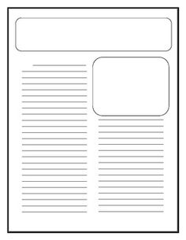
Newspaper templates from pinterest:
https://s-media-cache-ak0.pinimg.com/236x/51/40/a1/5140a17423f492b1a9959592e5f71d46.jpg
https://s-media-cache-ak0.pinimg.com/564x/aa/0a/0f/aa0a0fd8d271c778d0cc899b214b1559.jpg

Activity 9 - Cartoon Strip / Animation
This activity can be used as a part of a bigger project for a Science Magazine.

Scenario:
You have been asked to make a cartoon strip or animation based on the typical day of a CAASTRO researcher. This cartoon or animation will be used to promote the research centre to aspiring scientists from around Australia.

Instructions:
- Read the researcher profile that your teacher has given you.
- If there are any words you do not understand, check their meaning in a dictionary, on the internet, or ask your teacher.
- Firstly, write down some ideas of what might occur in the researcher’s daily work life. For example, what are they studying, did they make a new discovery, what are some of their work colleagues like?
- Once you have some ideas, organise them into a storyboard.
  - A storyboard is a quick overview of the main scenes of your comic or animation with: a simple picture of what is occurring, explanation of the action, the dialogue for the scene, any special effects or sounds to be added.
- Now that you have a draft storyboard, log into one of the websites below (your teacher may tell you which one to use) and create your cartoon strip or animation.
  - http://www.makebeliefscomix.com/
  - http://www.powtoon.com/
  - http://chogger.com/
- Once you have completed your cartoon or animation, publish it and present it to the class.

Example:
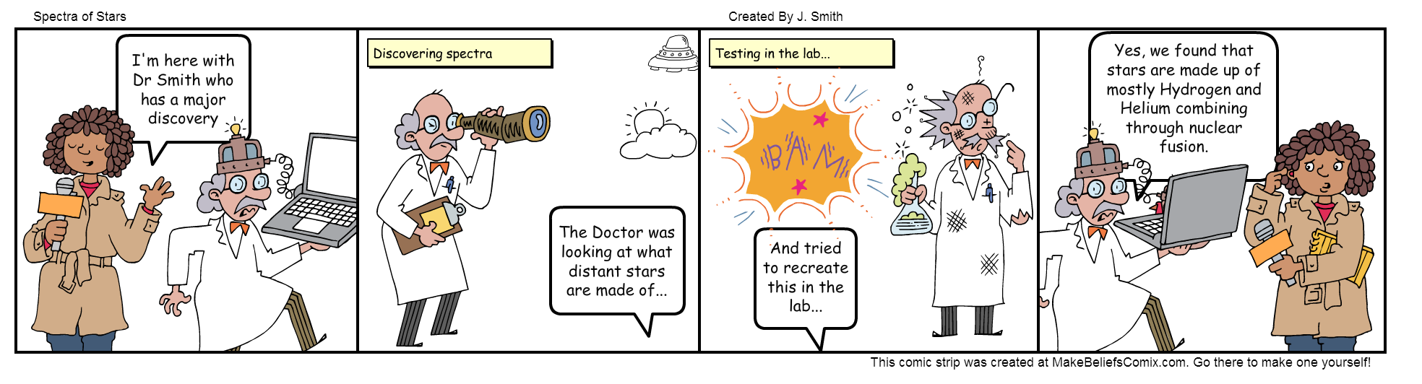

Further examples:
https://upload.wikimedia.org/wikipedia/commons/c/c7/Storyboarding_template_02.jpg
http://jimcleaveland.deviantart.com/art/The-Inexplicable-Adventures-of-Bob-storyboard-p-1-308900237

Activity 10 - Job advertisement
This activity can be used as a part of a bigger project for a Science Magazine.

Scenario:
Your researcher has just taken a promotion to become a Professor at their University. This means that their position needs to be filled with a suitable candidate. You have been asked to create a job advertisement to find the new candidate.

Instructions:
- Read the researcher profile that your teacher has given you.
- If there are any words you do not understand, check their meaning in a dictionary, on the internet, or ask your teacher.
- Look at the job advertisement example below, or search for a few on www.seek.com.au www.jobsearch.gov.au/job or www.jobsearch.com.au for ideas of what a job advertisement looks like.
- Write a job advertisement for your researcher’s position which identifies:
  - The skills required for the position
  - Qualifications required
  - Location of the job or if the job requires travel and a passport
  - What job opportunities are available (e.g. overseas travel, promotion opportunities)
  - Starting salary
- Once you have a rough draft you may want to include:
  - A company name and logo
  - Eye-catching and relevant pictures

Resources:
You may use Microsoft PowerPoint, Publisher or Word to create your job advert.
Or you can use the website: www.canva.com

Example:
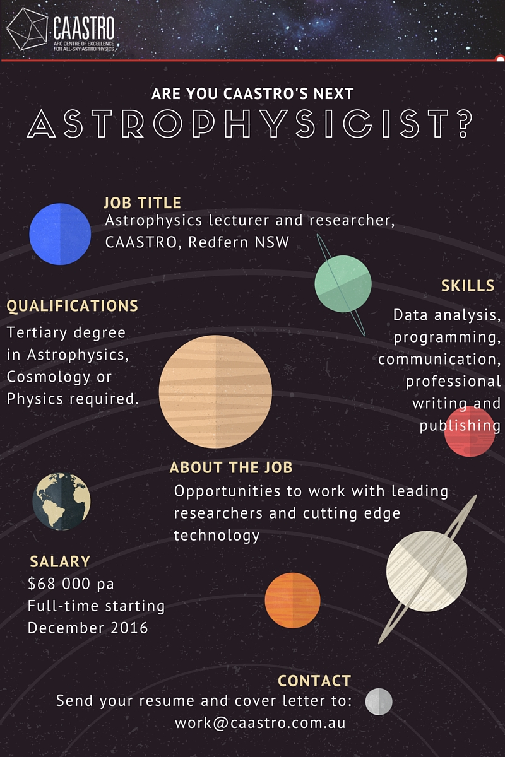

Activity 11 - This is your life interview
Scenario:
You have been called by Channel 9 to make a documentary about the life of a CAASTRO research scientist. Work in pairs with one of you acting as the researcher, and the other as the presenter. You are to come up with a list of questions and answers for your scientist about their childhood, education and research career. This interview will then be filmed, edited and presented to the class.

Once you have filmed the interview, you may want to edit the video to include titles, and interesting images and animations based on your researcher’s work.

Examples:
https://vimeo.com/54123538 Brian Schmidt - This is your life
https://www.youtube.com/watch?v=cXRdoncmYJ4 Steve Irwin - This is your life

List of video editing software:
- iPad / Apple iMovie - http://www.apple.com/ilife/imovie
Free on Apple products. Is easy to use but limited functionality.

- Windows Movie Maker - http://windows.microsoft.com/en-au/windows/movie-maker
Free on Microsoft products. Is easy to use but limited functionality.

- Lightworks - http://www.lwks.com/
Free to download. Is extremely powerful with high functionality, however, may take some learning.

- Adobe Premier - http://www.adobe.com/au/products/premiere.html
Paid software. Is extremely powerful with high functionality, however, may take some learning.

