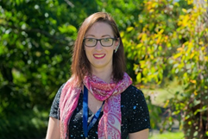
Researcher Profile: Fiona Panther

Fast Facts

Name
Fiona H. Panther

Job title
PhD Student, Australian National University

Where did you go to primary school and secondary school?
I grew up in the North East of England, and attended primary school and began high school there. I moved to New Zealand's North Island at age 15 and finished high school in Tauranga.

When you were a child, what did you want to be when you grew up?
I always loved science. Both my parents were dentists while I was growing up so I started off wanting to do something medical related - For many years I wanted to be a vet. When I was about 13 I learned more about nuclear physics and particle physics, and from that age I knew I wanted to be a physicist.

Where have you studied since finishing school?
I studied for my undergraduate degree in maths and physics at The University of Auckland in New Zealand, and also did my BSc(Hons) degree in physics there.

Where have you worked?
I worked during my undergraduate degree as a teaching assistant at The University of Auckland. I spent a few months working there as a research assistant too. I worked for Te Punaha Matatini, a centre for research excellence in complex systems, where I investigated how universities collaborate using tools developed in economics.

Describe your research in 150 characters or less.
I look at exploding stars called supernovae which don't behave in the "normal" way we expect them to.

What is the best part of your job?
Getting to go to work and think about space every day! I also really enjoy doing maths, and computer programming, so it's great to have a job doing the things I enjoy. It's exciting to talk to other people I work alongside too. Every day I learn something new and cool about the universe.

Name one impressive instrument that you’ve used for your research.
I recently used ANU's 2.3m telescope to look at a supernova that exploded in a galaxy 0.5 billion light years away! We used an instrument called WiFeS - the Wide Field Spectrograph - to split the light coming from the galaxy and the supernova into its constituent wavelengths (spectral lines). This enables us to measure the distance to the galaxy by measuring the Doppler shift of the spectral lines.

What skills are essential to your job?
The skills I use every day include maths, physics and computer programming. Even though I use maths every day, I'm not good at mental arithmetic, so I always need a calculator handy. I have to be able to communicate with my supervisors and colleagues too, so we have to be good at explaining what we're working on, and collaborating.

What advice would you give a school student who wants to become a scientist?
You don't have to be at the top of your class to become a scientist! Lots of amazing researchers I know didn't necessarily come top in the class in science. Research is a lot more about perseverance and being able to think outside of the box, something which school tests can't really measure. Being excited and passionate about science is just as (if not more!) important than being able to score full marks on a test.

What are some futuristic applications that might come from your research?
At the moment, we don't really understand properly what kind of stars produce supernovae, and there's a lot not known about the events I study because they're hard to see and not very useful for cosmology (we can't use them as distance indicators). My work might help narrow down what sort of star systems end their lives as these sub-luminous (feinter than ‘normal’) supernovae.

What do you do for fun in your spare time?
I play lots of sport - I love ultimate frisbee, cricket and I referee rugby. I like drawing, art and I play a few musical instruments, and I love cooking.

Media/videoscaitlin_adams_web
No

Twitter handle
@fipanther

Personal website
auntymatter.wordpress.com

Research in detail

I look at a type of exploding stars called ‘Type Ia supernovae’. This type of supernova can occur when there are two stars orbiting each other in a binary system. It is a very rare, catastrophic event that marks the last stage in the life of a star that is about 1.4 times the mass of our Sun. The supernovae that I study are not as bright as normal supernovae so they are called ‘sub-luminous’. We think they can occur for a type of star that lives for around 10 billion years before exploding as a ‘sub-luminous’ Type Ia supernova.

When these supernova events happen, we think they release a lot of positrons (the antimatter counterpart of electrons). At the centre of our own galaxy, the Milky Way, an excess of positrons has been detected and my research may determine if ‘sub-luminous’ Type Ia supernovae are the source of these positrons. I model the way positrons travel through the galaxy, and investigate the types of galaxies where sub-luminous supernovae occur, and how often they occur.

Images
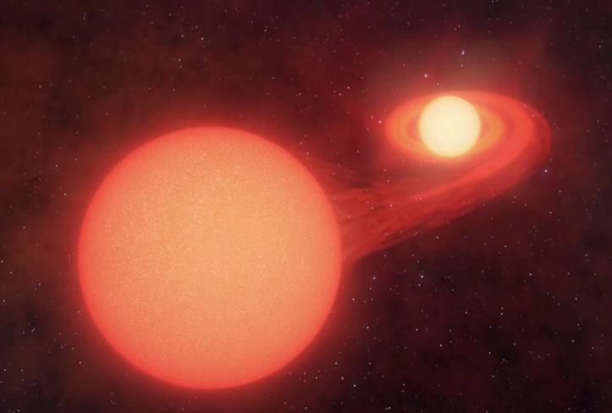

Two stars in a binary system before a Type 1a supernova explosion.
Image credit: CAASTRO/Swinburne Astronomy productions

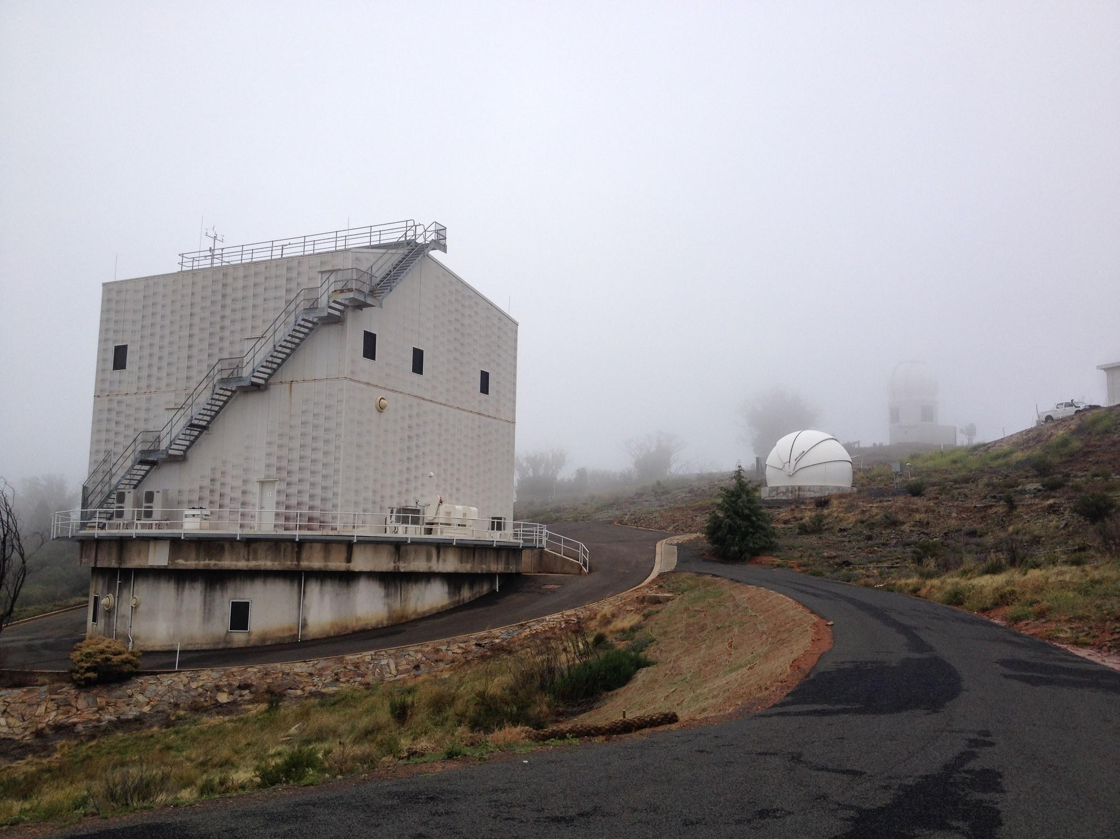
Australian National University 2.3 metre telescope. Image credit: Fiona Panther

