Life Cycle of Stars

This resource can be used on its own or in conjunction with the year 11 “Cosmic Engine” YouTube video.

Table of contents
Click on the links below to jump to the relevant section.

Table of contents
Glossary
Revision Videos
Practice Questions
Question 1 - Stellar Evolution
Question 2 - Stellar Properties
Question 3 - Hertzsprung-Russell Diagrams
Online Interactives
Interactive 1 - Stellar Evolution
Interactive 2 - Interactive H-R Diagram
Interactive 3 - Evolution from Main sequence to giant stage
Interactive 4 - Hertzsprung-Russell Diagram Explorer
Practical Activities
Activity 1 - Creating a HR Diagram of the Pleiades
Useful Links

Glossary
The following terms may be cited during the video conferencing session. If students need assistance, refer them to the ‘Revision Videos’ section or any Physics textbook.

Terms | Definition
Star
Galaxy
Universe
The Big Bang
Light year (ly)
Black hole
Main sequence star
White Dwarf
Red giant
Neutron star
Nebula
Accretion
Supernova
Fusion
Ionisation
Photon
Luminosity
Apparent magnitude
Absolute magnitude
Solar mass (M☉)
Hertzsprung-Russell (H-R) Diagram

Extra terminology

Terms | Definition
Red supergiant
Blue giant
Blue supergiant
Hypergiant

Revision Videos
The following is a list of useful revision videos. Students can:
- Take notes on the videos for themselves; OR
- Review one or more of the videos for their classmates as a homework exercise, giving each video a rating and commenting on how well the video communicated the science content.

- Accretion and the birth of a star
https://www.youtube.com/watch?v=mkktE_fs4NA
Science Channel: How the Universe Works - A Star is Born

- The life cycle of stars and nuclear fusion
https://www.youtube.com/watch?v=PM9CQDlQI0A
Institute of Physics: The Life Cycle of Stars

- Nuclear fusion
https://www.youtube.com/watch?v=Ux33-5k8cjg
Vertasium: Where does the sun get its energy?

- Fission and fusion
https://www.youtube.com/watch?v=yTkojROg-t8
The Science Channel: Fission and Fusion

- H-R diagram made from Omega Centauri
https://www.youtube.com/watch?v=jiSN95WX1NA
utexascnsquest: H-R diagram animation

- Stars, spectra and the H-R diagram
https://www.youtube.com/watch?v=ld75W1dz-h0
PBS CrashCourse: Stars - Crash Course Astronomy #26

- Brian Schmidt explains how he discovered that the universe is expanding
https://www.youtube.com/watch?v=YHBvOOX3RJQ
Veritasium: Physics Nobel Prize 2011 - Brian Schmidt

- Star size comparison
https://www.youtube.com/watch?v=HEheh1BH34Q
morn1425: Star Size Comparison HD

- Black hole and supermassive black hole size comparison
https://www.youtube.com/watch?v=QgNDao7m41M
morn1415: Black Hole Comparison

- Types of Stars explained
https://www.youtube.com/watch?v=gT8WrjBEaHM
The Open University: Types of Stars

Practice Questions

Question 1 - Stellar Evolution

- Complete the following table:

Star type | Energy source (elements that are fused)
Main Sequence
Red giant
Red supergiant
White dwarf

- Explain why only stars of very large initial mass may develop into a supernova.

- Explain how white dwarf stars differ from main sequence stars.

- Where do naturally-occurring elements heavier than hydrogen and helium come from?

- Identify the following objects in the stellar evolution chart.

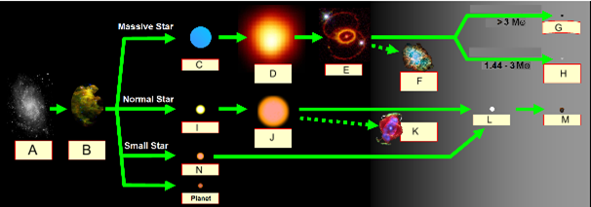

Image edited from https://upload.wikimedia.org/wikipedia/commons/0/0f/Stellar_evolution_Hebrew.png
Attribution: DMY at Hebrew Wikipedia [GFDL (http://www.gnu.org/copyleft/fdl.html) or CC BY-SA 3.0 (http://creativecommons.org/licenses/by-sa/3.0)], via Wikimedia Commons

A |  |  | F |  |  | K
B |  |  | G |  |  | L
C |  |  | H |  |  | M
D |  |  | I |  |  | N
E |  |  | J

Question 2 - Stellar Properties

- Describe the relationship between a star's temperature and its colour.

- What two factors affect a star’s luminosity (by looking at an HR diagram)?

- Re-order these two lists from hottest to coolest stars:
  - Star colours: Yellow, Red, Orange, White, Blue
  - Spectral classes: M, G, A, K, B, O, F

Question 3 - Hertzsprung-Russell Diagrams

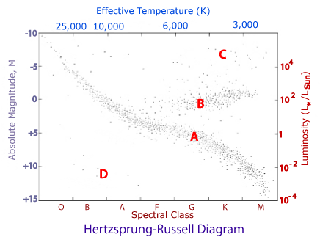
HR Diagram from: http://www.atnf.csiro.au/outreach/education/senior/cosmicengine/stars_hrdiagram.html

Answer the following questions using the Hertzsprung-Russell Diagram provided above.

- Indicate the regions of:
  - hottest stars
  - coolest stars
  - biggest stars
  - smallest stars
  - brightest stars
  - least bright stars

- Using the HR diagram, which letters (A, B, C or D) represent the region of:
  - main sequence stars
  - white dwarfs
  - Giants
  - Supergiants

- On the HR diagram, Label the evolutionary track (evolution path) for an average mass star (1 solar mass) using a pen of a different colour.

Online Interactives

Interactive 1 - Stellar Evolution
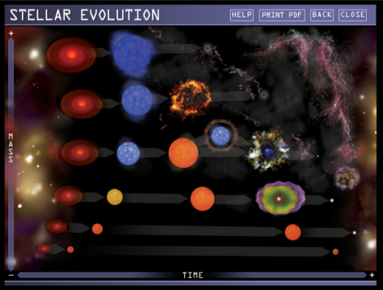 | Chandra X-Ray Observatory, NASA, United States  http://chandra.harvard.edu/edu/formal/stellar_ev/stellar_ev_flash.html  This interactive shows the various stellar evolutions of stars based on their masses. It outlines what is occurring at each stage with a real example for each stage collected by the Chandra X-Ray Observatory.

Instructions:
- Select “Continue” and to get to the stellar evolution chart displaying images of various stages a star could reach during its lifetime.
- Hover the mouse over each stage to read its name. Click one of the stages to learn about it in detail.
- Select “Play” on the image to see an animation of the evolutionary process.
- Hover the mouse over “Comparison” to see a real example of the selected stage from the Chandra X-Ray Observatory.
- Select “Back” or “Next” to move back and forth between the stages of that particular stellar evolution.
- Select “Home” to return to the stellar evolution chart.
- Select “Print PDF” to download a PDF version of this interactive (this can take some time).

Interactive 2 - Interactive H-R Diagram
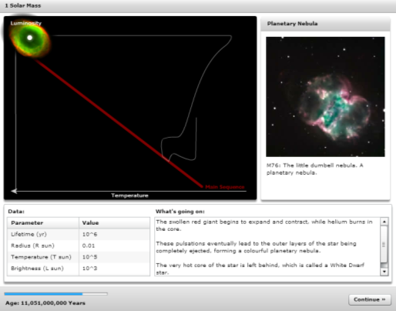 | Edward Gomez and Jon Yardley, Las Cumbres Observatory Global Telescope Network (LCOGT)  https://lcogt.net/files/flash/hr-diagram/main.html  This interactive allows students to explore the evolution of a star of 1 solar mass. It displays its evolutionary pathway on the H-R diagram, an image of a real example for each key stage in the evolutionary process, description of stellar properties and what is occurring at each stage.

Instructions:
- Click “START” on the home screen. The top right corner of the interactive notes what stage of the evolution the star is in (e.g. Stellar nursery, Main sequence star, White dwarf), and the bottom left corner indicates the age of the star.
- Read “What’s going on” for a brief explanation of the processes occurring at each stage of evolution.
- Click “Continue” and watch the animation of the star on the H-R diagram. At each stage the stellar properties are provided in the “Data” table.
- Click “Restart” to restart the animation.

Interactive 3 - Evolution from Main sequence to giant stage
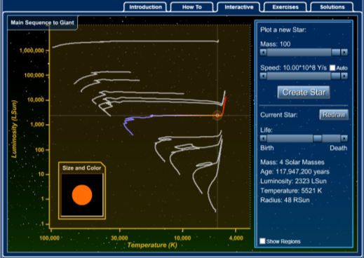 | Rochester Institute of Technology, New York, United States  http://spiff.rit.edu/classes/phys230/lectures/star_age/evol_hr.swf  This interactive shows the evolution of simple non-metal stars evolving from the main sequence to the start of their giant phase. The interactive includes exercises for students, along with stellar properties for each star along its evolution.

Instructions:
- Select “Introduction” tab to learn about the history of the H-R diagram.
- Select “How to” to learn how to operate the interactive.
- Select “Interactive” to start.
- Move the “Mass” slider bar to select the desired mass of the star.
- Check the “Auto” box in the speed section then click “Create Star”. Check
“Show Regions” to display regions where the main sequence stars and the giants are located.
- Once the animation is complete, click on any part of the star’s evolutionary path on the H-R diagram to see the size, colour and the stellar properties of the star at that particular point in its life.
- Run the simulation for different masses of the star for differences and/or similarities.
- Select “Exercises” to access questions associated with this interactive. The answers to these questions can be accessed by selecting the “Solutions” tab.

Interactive 4 - Hertzsprung-Russell Diagram Explorer
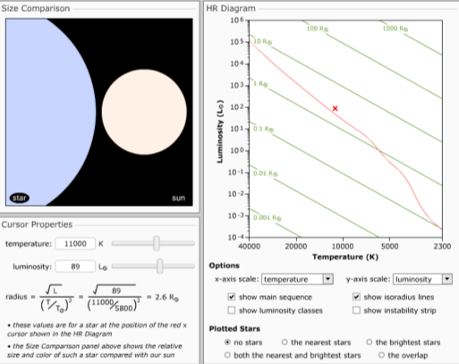 | Astronomy Education at the University of Nebraska-Lincoln  http://astro.unl.edu/naap/hr/animations/hr.html  This interactive allows users to compare stars on the HR diagram to the Sun by either selecting a point on the HR diagram, or by designating/assigning temperature and luminosity values.

Instructions:
- Click anywhere on the HR diagram on the right to see the temperature and luminosity values for a star in the region that is selected (indicated by a red cross x). The radius is calculated using the formula below and a size comparison to the sun is shown above.
- Click the temperature or luminosity slider bar, or manually input these values into the text box to change the values. The new star will be indicated by a red cross x on the HR diagram and size comparison will be shown.
- The HR diagram can be adjusted by selecting various settings under the “Options” located directly below the diagram.
- Specific groups of stars can be plotted onto the HR diagram by selecting the desired group under “Plotted Stars”.
- Select the “reset” button above the HR diagram to reset the interactive, or “help” to read about the interactive.

Practical Activities

Activity 1 - Creating a HR Diagram of the Pleiades

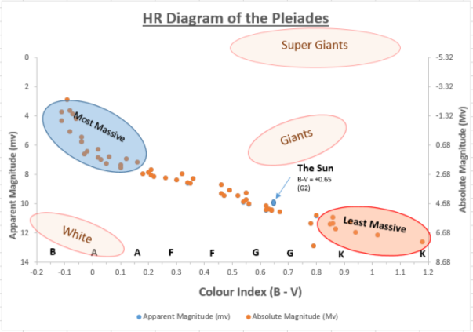
This investigation uses data from the Pleiades cluster to create a Hertzsprung-Russell diagram in Microsoft Excel.

Method:
Follow the method given in the link below.

Source:
Australia Telescope Outreach and Education, CSIRO, Australia http://www.atnf.csiro.au/outreach/education/senior/astrophysics/stellarevolution_pleiadesact.html

Note:
- To plot absolute magnitude on the same graph you need to add a secondary axis and adjust the max/min values of the secondary axis.

Useful Links
Below is a list of further links to supporting materials that may assist in teaching this topic.

- https://www.youtube.com/watch?v=b22HKFMIfWo
PBS CrashCourse - The Sun: Crash Course Astronomy #10

- https://www.youtube.com/watch?v=DEw6X2BhIy8
BBC 2 - Wonders of the Universe: Star Death and the Creation of Elements (Brian Cox)

- http://goo.gl/2KU8DK
Space.com - Your Universe: The Life And Death Of Stellar Fusion Engines

- http://ciera.northwestern.edu/Research/stellar_evolution/stellar_evolution.php#
Ciera, Northwestern University - stellar evolution animations. Animations can be downloaded

- https://www.youtube.com/watch?v=uRGZFJ98hlg
John Fleurant - Star Spectral Types and Star Sizes

- https://www.youtube.com/watch?v=2uxfGNxNMg8
MrNinjaMittens - Star Types & Classifications

- http://astro.unl.edu/classaction/browser.html
Astronomy Education Group, University of Nebraska-Lincoln - Class Action. An interactive tool containing information, quizzes, animations and images.

- http://www.atnf.csiro.au/outreach//education/senior/cosmicengine/sun_questions.html
CSIRO - Questions on Sun - Earth Interactions

- http://www.atnf.csiro.au/outreach/education/senior/cosmicengine/cosmology_questions.html
CSIRO - Questions on Cosmology & Big Bang

- http://skyserver.sdss.org/dr1/en/proj/advanced/hr/intro.asp
SDSS - Making a HR diagram

- http://www3.gettysburg.edu/~marschal/clea/CLEAsoft_overview.html
Department of Physics, Gettysburg College - CLEA. Old but excellent interactive applications that can be downloaded to Windows 7 & 8 machines.

- http://www.learner.org/teacherslab/science/light/color/spectra/
Annenberg Learner - stellar spectra and classification

- https://in-the-sky.org/ngc3d.php
Dominic Ford - 3D interactive map of the universe

- http://mrges.com/labs/assets/Star%20Evolution.pdf
Mr Goldstein’s Earth Science - Stellar Evolution Lab: The life-cycle of a star

- http://chandra.harvard.edu/resources/handouts/constellations/activities/stellar_evol.pdf
Chandra X-Ray Observatory, NASA - From Earth to the Universe Activity: Stellar Evolution Scavenger Hunt

