Earth, Moon and Sun

These worksheets are designed to be read by students before viewing the CAASTRO in the Classroom session “Reason for seasons & Days in a phase”. The ‘Pre-visit activities’ can be completed prior to watching the video and the ‘Post-visit activities’ are provided as suggestions for follow-up activities.

Table of contents

Table of contents
Pre-visit Activities
Glossary
Revision Videos
Post-visit Activities
Practice questions
Question 1 - Ancient views of the universe
Question 2 - Observatories
Question 3 - Light and telescopes
Question 4 – Earth, Moon and Sun positions
Online Interactives
Interactive 1 – WorldWide Telescope
Interactive 2 - Eclipses
Interactive 3 - Phases of the Moon
Interactive 4 - Explaining the seasons
Practical Activities
Activity 1 - Making a telescope
Activity 2 - Modelling eclipses and seasons
Useful Links

Pre-visit Activities

Glossary
The following terms may be used during the video session. If students need assistance, refer them to the ‘Revision Videos’ section, an online dictionary or reference book.

Terms | Definition
Astronomy
Axis
Dwarf planet
Geocentric model
Gravity
Heliocentric model
Lens
Lunar eclipse
Moon
Observatory
Orbit
Phase of Moon
Planet
Reflecting telescope
Refracting telescope
Rotation
Season
Solar eclipse
Solar System
Telescope
Time ball

Glossary with answers
Terms | Definition
Astronomy | The study of space and the objects in it
Axis | An imaginary line around which rotation occurs
Dwarf planet | A celestial body large enough to be rounded by its own gravity which orbits a star, but has not cleared the neighbourhood around its orbit
Geocentric model | An outdated model of the solar system and universe where all celestial objects orbit the Earth
Gravity | An attraction force between two objects
Heliocentric model | The currently accepted model of the solar system, where all planets and other objects orbit the Sun
Lens | An optical device made of glass or plastic that is used to focus light
Lunar eclipse | When the Moon passes into Earth’s shadow and goes dark; occurs when the Sun, Moon and Earth are aligned with Earth in the middle
Moon | A natural object that moves around a planet
Observatory | A building used to house equipment such as telescopes in order to study the sky
Orbit | The path of an object moving around another object due to gravity
Phase of Moon | Describes how much of the Moon can be seen at any point in time, e.g. full moon
Planet | An object that moves around a star in an elliptical orbit (in the shape of an oval). To be a planet, an object must be massive enough to be round and be the largest object in and near its orbit.
Reflecting telescope | A telescope that uses a mirror to collect and focus light, in addition to a number of lenses
Refracting telescope | A telescope that uses a number of lenses to collect and focus light
Rotation | A turning motion around an axis
Season | One of four periods throughout the year (Summer, Autumn, Winter, Spring) marked by different weather patterns, temperatures and number of daylight hours
Solar eclipse | Occurs when the Moon passes in between the Sun and Earth, blocking the Sun’s light for a short period of time
Solar System | An arrangement of planets, asteroids, comets and other objects that orbit the Sun due to gravity
Telescope | A device that makes distant objects in the sky appear clearer and closer
Time ball | A sphere that falls down a vertical rod at a certain time every day; used to keep time in the days before people had clocks, watches etc

Revision Videos
The following is a list of useful revision videos. Students can:
- Take notes on the videos for themselves; OR
- Review one or more of the videos for their classmates as a homework exercise, giving each video a rating and commenting on how well the video communicated the science content.

- Ancient astronomy vs. current astronomy:
https://www.youtube.com/watch?v=_B3eKQMQaeo
Discovery - The History of Astronomy K4602DVD

- Astronomy through the ages (history of astronomy):
https://www.youtube.com/watch?v=MMyTeqiNTjw
Amy Leniart - Early Astronomers

- Difference between refractors and reflectors
https://www.youtube.com/watch?v=mYhy7eaazIk
CrashCourse – Telescopes: Crash Course Astronomy #6

- Various space telescopes that are currently used (with beautiful pictures):
https://www.youtube.com/watch?v=YquwWWINkCY
Hubblecast - Beyond Earth: Telescopes in Space

- Geocentric and heliocentric models explained
https://www.youtube.com/watch?v=khIzr6610cQ
SciShow Space - How we figured out that Earth goes around the Sun

- Types of eclipses
https://www.youtube.com/watch?v=rVE8PFYlwSM
Physics Girl – What’s the difference between a solar and lunar eclipse?

- Seasons explained with an animation
https://www.youtube.com/watch?v=WgHmqv_-UbQ
California Academy of Sciences – Why do we have different seasons?

Post-visit Activities

Practice Questions

Question 1 – Ancient views of the universe

- Conduct research to find out how these ancient cultures viewed the night sky, and some of the stories and myths they created to explain what they saw.

- Chinese

- Greeks

- Australian aboriginals

- Egyptians

- Conduct research to find out what each of these people contributed to our understanding of the solar system and the rest of the universe.

- Ptolemy

- Aryabhata

- Nicolaus Copernicus

- Galileo Galilei

Question 2 – Observatories

- When it was built, Sydney Observatory was placed on Sydney’s highest hill. Why did that seem a good place to put it and why can’t it be used as a research observatory now?

- This observatory, Mohon Del Trigo in Spain, was built in 1902. Explain why this mountain in the Sierra Nevada range (2600m elevation) is a better location for an observatory than a hill in a city.

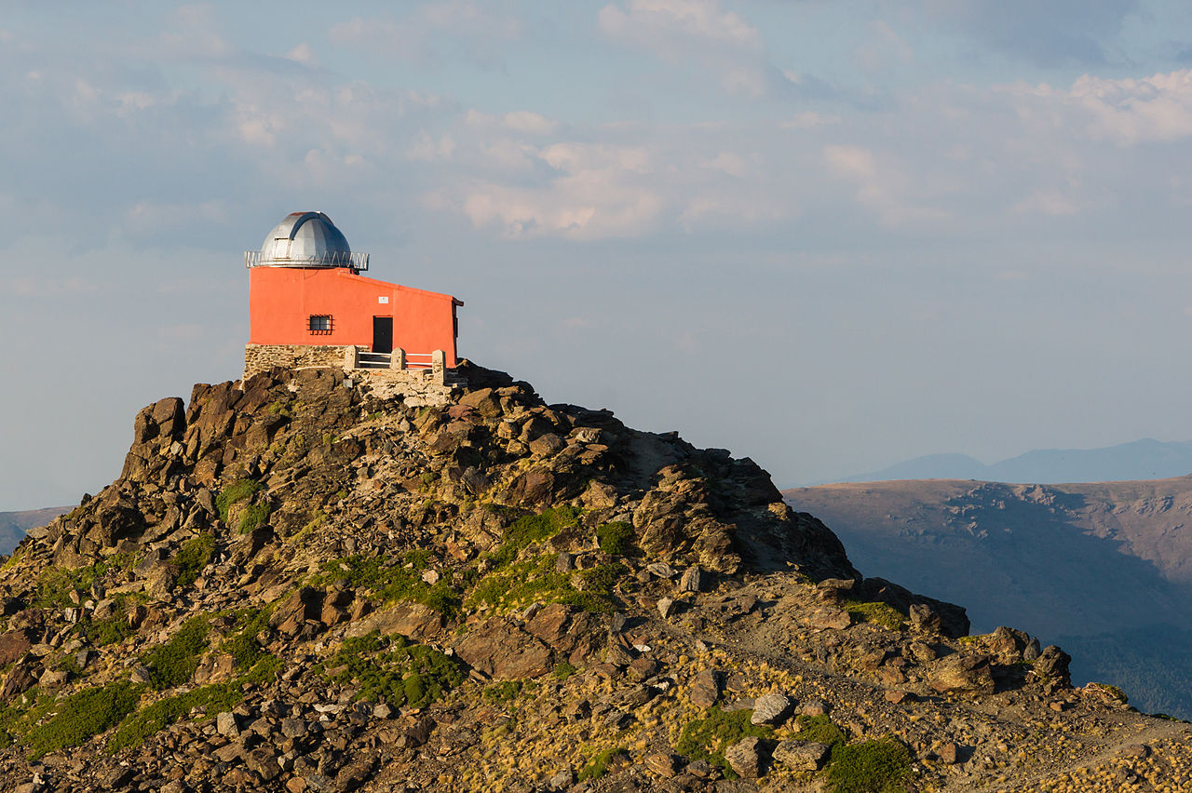
Image: Jebulon via Wikicommons (public domain)

Question 3 – Light and telescopes

- Explain what is meant by (i) reflection of light (ii) refraction of light.

b) (i) This diagram shows the path of light through a simple reflecting telescope. Label all parts of this diagram.

(ii) What are some of the advantages and disadvantages of reflecting telescopes compared to refracting telescopes?

TYPE OF TELESCOPE | ADVANTAGES | DISADVANTAGES
Refracting

Reflecting

Question 4 – Earth, Moon and Sun positions

a) (i) Identify the type of eclipse that would occur when the Sun, Earth and Moon are in the positions shown below.
(ii) Indicate where on Earth people would see a total eclipse and a partial eclipse.

b) Using the diagram and your knowledge of the movement of the Earth, Moon and Sun, explain why summer in the southern hemisphere occurs at the same time as winter in the northern hemisphere.
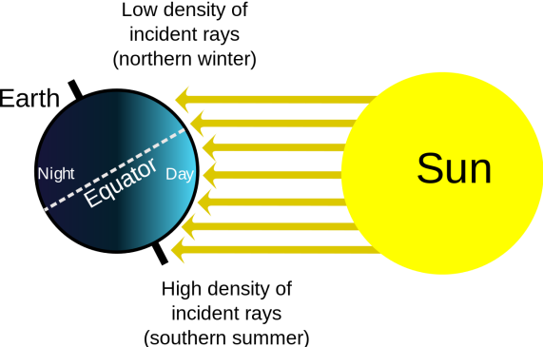

Online Interactives

Interactive 1 – WorldWide Telescope
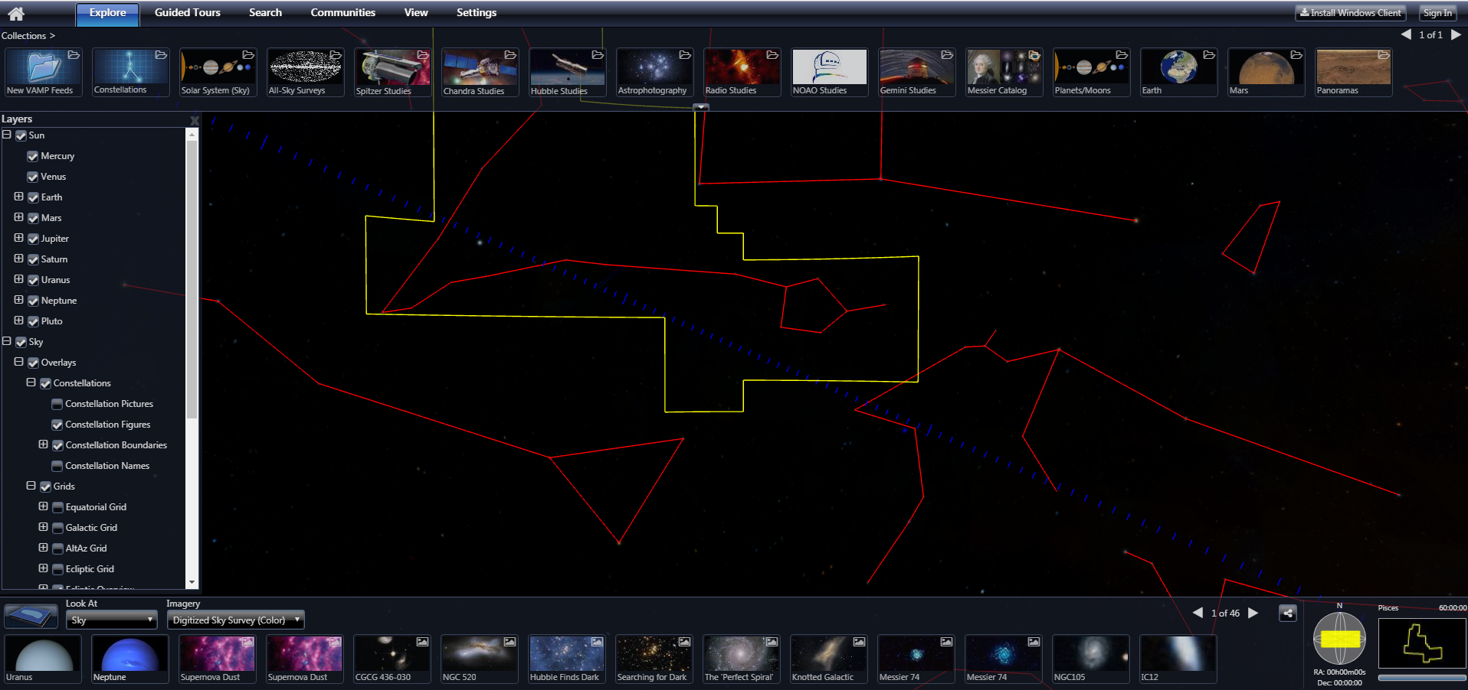 | WorldWide Telescope,  American Astronomical Society  http://www.worldwidetelescope.org/home  This amazing interactive lets you explore the solar system, telescopes and much, much more!

Instructions:
- Click “Run WorldWide Telescope on the Web” to start.
- Explore each of the “Collections” at the top by selecting each one in turn. You’ll be able to view planets and constellations, and you’ll also be able to see some images from NASA’s space telescopes.
- Select “Guided Tours” from the top menu to view short videos with extra information about space phenomena.

Interactive 2 - Eclipses
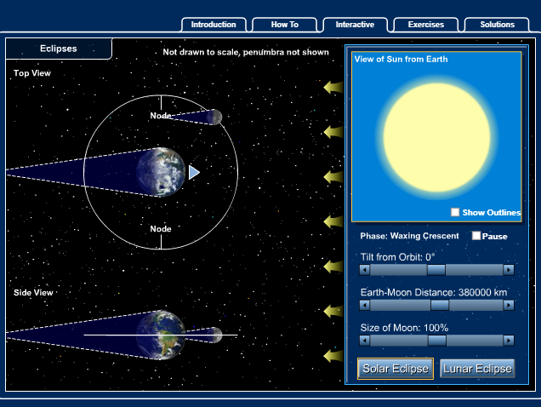 | McGraw-Hill Education  https://highered.mheducation.com/olcweb/cgi/pluginpop.cgi?it=swf::640::480::/sites/dl/free/007299181x/220730/eclipse_interactive.swf::Eclipse%20Interactive  This interactive allows you to see solar and lunar eclipses from different angles, and also lets you change three parameters.
Instructions:
- Select “Solar Eclipse”.
- Watch the eclipse once then explore what happens when you change the tilt from orbit, Earth-Moon distance and size of the Moon. Make predictions about what will happen before you make any changes.
- Select “Exercises” and see if you can answer the questions. When you’re ready, see how well you did by selecting “Solutions”.
- Repeat the above three steps for “Lunar Eclipse”.

Interactive 3 - Phases of the Moon
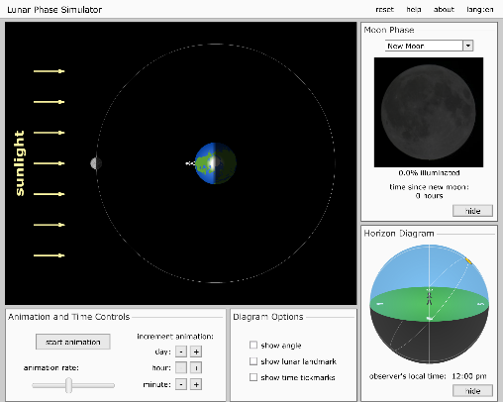 | University of Nebraska-Lincoln, Nebraska, United States  http://astro.unl.edu/naap/lps/animations/lps.swf  This interactive provides a detailed explanation of the phases of the moon. Users can easily adjust the time of day for the observer on the Earth and the position of the Moon. It also clearly shows how, when viewed from the Earth, the distance between the Moon and the Sun appears to change over time.

Instructions:
- Click “start animation” to start the Moon orbiting around the Earth and the Earth spinning on its own axis. The button changes to “pause animation” which can be pressed to stop the animation.
- The Moon Phase window shows how the Moon appears to an observer on the Earth.
- The Horizon Diagram window shows the position of the Moon relative to the Sun in the sky as seen by an observer on the Earth.
- Move the “animation rate” slide to increase/decrease the speed of the animation.
- Click the “-” and “+” buttons below “increment animation” to adjust the position of the Moon on the orbital path or the Earth on its axis. These can be manually adjusted by clicking and dragging directly on the Moon or the Earth.
- Additional options can be added to the interactive by ticking the checkboxes in the Diagram Options window.

Interactive 4 - Explaining the seasons
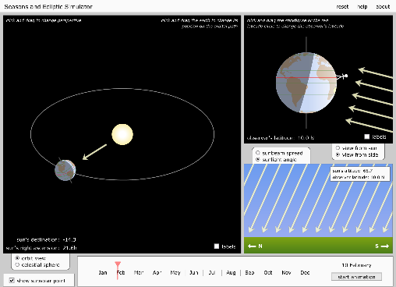 | University of Nebraska-Lincoln, Nebraska, United States  http://astro.unl.edu/naap/motion1/animations/seasons_ecliptic.swf  This interactive provides an animated model of the Earth orbiting the Sun, providing an excellent visualisation of changes in the angle and area of the sun’s light hitting the surface of the Earth. An excellent tool for exploring the concept of seasons.

Instructions:
- Click “start animation” button to start the Earth orbiting around the Sun. Observe how the area over which sunlight hits the Earth changes as the earth orbits the Sun (note: the rate at which the Earth spins on its own axis is extremely slow).
- Click and drag the Earth to change its position on the orbital path.
- Click and drag the orbital path up/down to adjust the plane of the orbit (providing a better view of a hemisphere of interest).
- Click and drag the stickfigure up/down to adjust the latitude of the observer on Earth.
- The “subsolar point” is the point on a planet where the sun’s rays are hitting the planet exactly perpendicular to its surface. It demonstrates the hottest day for that latitude.
- Various views are available for selection:
  - “orbit view” (default) - shows how the tilt of the Earth’s axis affects the amount of sunlight it receives on different parts of its surface.
  - “celestial sphere” - shows how the sun appears to moving across the sky according to the observer on Earth (the Earth’s axis is not tilted in the POV of the observer).
  - “sunlight angle” (default) - shows how the angle of the sunlight to the ground changes over time at a specific latitude.
  - “sunbeam spread” - shows how much the sunbeam spreads according to the observer on the Earth at a specific latitude over time.
  - “view from side” (default) - shows how the amount of sunlight on different parts of the Earth changes over a year, and why the seasons in the southern hemisphere are opposite to the northern hemisphere.
  - “view from sun” - shows how the tilt of the Earth’s axis changes the position of the subsolar point above and below the equator over the year.

Practical Activities

Activity 1 - Making a basic telescope
This activity uses simple, easily accessible materials to demonstrate how refracting telescopes work. Students then explore how to point a telescope at a distant object and focus the image.

Safety warning:
Do not use the lenses or telescope to look at the Sun!

Equipment:
- A4 piece of cardboard
- Empty paper towel roll
- Sticky tape
- 2 × biconvex lenses with different focal lengths (e.g. 150 mm and 500 mm double convex)

Method:
- Roll up the piece of cardboard the long way to form a tube that slides snugly inside the paper towel roll. Take the cardboard tube out of the paper towel roll and use sticky tape to hold the shape of the cardboard tube.
- Tape the edges of the lens with the longest focal length (objective lens) to the end of the paper towel roll.
- Tape the edges of the lens with the shortest focal length (eyepiece lens) to the end of the cardboard tube.
- Insert the empty end of the cardboard tube into the paper towel roll. Look through the eyepiece lens and point the objective lens at a distant object.
- Slide the tube in and out of the roll until the distant object comes into focus. The image should look upside-down and magnified.

Note: Depending on the focal lengths of the lenses, the cardboard tube and paper towel roll may need to be shorter or longer. You can also use other types of cardboard rolls.

Activity 2 – Modelling eclipses and seasons
This activity allows students to model solar and lunar eclipses, as well as seasons. It is best done in groups of 4 in a darkened room. The balls can be attached to fishing line by pushing a paper clip into them and tying the fishing line to the clip.

Equipment:
- A large torch
- A styrofoam ball the size of a softball attached to fishing line
- A Styrofoam ball the size of a ping pong ball attached to fishing line
- One black texta
- One camera (a phone will do)

Method:
- Allocate one student to be the Sun and give them the torch. Another student will be the Moon (small ball) and another will be the Earth (larger ball). The 4th member of the group is the recorder and will take photos.
- On the larger ball, use the texta to mark in the positions of the north and south poles, remembering that the Earth is tilted at 23.5°.
- With the room lighting dimmed, have the students move into positions that would correspond to a solar eclipse and take a photo.
- Repeat the process for a lunar eclipse.
- Have students draw the country they live in on the larger Styrofoam ball (“Earth”) and put an X on their exact location.
- Have students model “summer” and “winter” for their location and take photos.
- Each group is to make an infographic (using Word or similar) that incorporates their photos as well as brief explanations of what each one shows.

Useful Links
Below is a list of further links to supporting materials that may assist in teaching this topic.

- https://www.youtube.com/watch?v=wuhNZejHeBg
NASA Goddard - Lunar Eclipse Essentials

- http://astro.unl.edu/classaction/animations/telescopes/telescope10.swf
University of Nebraska-Lincoln - Telescopes

- http://faculty.buffalostate.edu/sabatojs/courses/GES131/figures/ReasonForSeasons.swf
Pearson Education - Much more than distance - How Earth’s tilted axis causes the Seasons

- http://sciencenetlinks.com/interactives/moon/moon_challenge/moon_challenge.swf
Science NetLinks - Lunar Cycle Challenge

- http://www.jpl.nasa.gov/edu/teach/activity/moon-phases/
Jet Propulsion Laboratory - Moon Phases

