Solar System and Beyond

These worksheets are designed to be read by students before viewing a CAASTRO in the Classroom video conferencing session or a recording of a past video conference. The ‘Pre-visit activities’ can be completed prior to the video conference session and the ‘Post activities’ are provided as suggestions for follow-up activities.

Table of contents

Table of contents
Pre-visit Activities
Glossary
Revision Videos
Post-visit Activities
Online Interactives
Interactive 1 - Solar System scope
Interactive 2 - Finding the invisible
Interactive 3 - Phases of the Moon
Interactive 4 - Explaining the seasons
Practical Activities
Activity 1 - Constellations
Activity 2 - Pocket Solar System
Activity 3 - Making a basic telescope
Activity 4 - Observing a strange new planet
Useful Links

Pre-visit Activities

Glossary
The following terms may be used during the video conferencing session. If students need assistance, refer them to the ‘Revision Videos’ section, an online dictionary or reference book.

Terms | Definition
Asteroid
Galaxy
Gravity
Milky Way
Moon
Optical Telescope
Orbit
Planet
Radio Telescope
Solar System
Star
Sun
Universe

Glossary with answers

Terms | Definition
Asteroid | A small rocky object that moves around the Sun
Galaxy | A system of stars, planets, gas and dust, held together by gravity
Gravity | An attraction force between two objects
Milky Way | The galaxy that contains the Solar System
Moon | A natural object that moves around a planet
Optical Telescope | A device that makes distant objects in the sky appear clearer and closer
Orbit | The path of an object moving around another object due to gravity
Planet | An object that moves around a star in an elliptical orbit (in the shape of an oval). To be a planet, an object must be massive enough to be round and be the largest object in and near its orbit.
Radio Telescope | A device that detects radio signals from distant objects in the sky
Solar System | An arrangement of planets, asteroids, comets and other objects that orbit the Sun due to gravity
Star | A huge ball of gas that emits light and other types of radiation
Sun | The star at the centre of the Solar System
Universe | All existing space and matter including stars, planets and galaxies

Revision Videos
The following is a list of useful revision videos. Students can:
- Take notes on the videos for themselves; OR
- Review one or more of the videos for their classmates as a homework exercise, giving each video a rating and commenting on how well the video communicated the science content.

- Ancient astronomy vs. current astronomy:
https://www.youtube.com/watch?v=_B3eKQMQaeo
Discovery - The History of Astronomy K4602DVD

- Astronomy through the ages (history of astronomy):
https://www.youtube.com/watch?v=MMyTeqiNTjw
Amy Leniart - Early Astronomers

- Difference between refractors and reflectors:
https://www.youtube.com/watch?v=WvLspPgC1EU
Juan Demarco - How does a telescope work

- Various space telescopes that are currently used (with beautiful pictures):
https://www.youtube.com/watch?v=YquwWWINkCY
Hubblecast - Beyond Earth: Telescopes in Space

- Explanation of how radio telescopes work using Parkes Telescope (Australian context):
https://www.youtube.com/watch?v=Igmx4WW-8K8
CSIRO - A tour of the Parkes radio telescope (1990)

Post-visit Activities

Online Interactives

Interactive 1 - Solar System scope
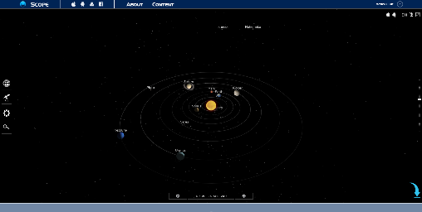 | Solar System Scope, INOVE, Europe  http://www.solarsystemscope.com/  This interactive provides a detailed view of the Solar System, in particular the Sun, planets, dwarf planets, moons and comets. There are several variables that can be adjusted such as the point of view, time/date of viewing, size of the planet and the orbit etc.

Instructions:
- Click the interactive to start.
- The slider on the right controls zooming - move it up = zoom in, move it down = zoom out. Scrolling with the mouse also controls zooming - scroll up = zoom in, scroll down = zoom out.
- The “planet” button () on the left displays the Solar System viewed from the outer space.
- The “telescope” button () on the left displays the Solar System viewed from Earth.
- The “settings” button () on the left provides options to select for viewing the Solar System.
- The “search” button () on the left is used to search for a specific planet, dwarf planet, comet, constellation, or major star.
- Click on the Sun or a planet in the solar system to access quick information about it.
- Double click on the Sun or a planet/dwarf planet/moon to zoom in and access more information about it:
  - Select “orbit” to view the object very closely
  - Select “planet system” (only available for the planets and moons) to view the planet system it belongs to
  - Select “structure” (available to certain objects) to view what it looks like inside (internal structure)
  - Select “show info” to access quick information or to view labels of an object’s internal structure
- The “play” button on the bottom shows how the Solar System moves over time. Move the slides to increase/decrease the time forwards/backwards.
- Click the date to choose a specific day, month and year to view the Solar System (most useful in “telescope” view).
- Click the “world” button on the bottom to select the location of the Earth to view the Solar System (most useful in “telescope” view).
- Retrograde motion of planets can be observed in the “telescope” view by selecting a planet of choice (innermost planets are easiest) and clicking the “play” button with the following settings:
  - Tick “keep same day-time”
  - Move the slider to “days”

Interactive 2 - Finding the invisible
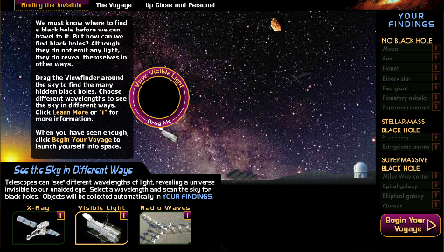 | Space Telescope Science Institute, Maryland, United States  http://hubblesite.org/explore_astronomy/black_holes/modules.html  Most of this interactive site is about Black Holes, but this section (Finding the invisible) provides images of various celestial objects through different types of telescopes (using different electromagnetic radiation), demonstrating how different instruments can be used to study specific features of objects in space.
Instructions:
- Click and drag the “Viewfinder” around the sky to find and view various celestial objects through the visible light telescope.
- When a new object is found, the table on the right identifies the object by highlighting the link to the object, making it active for information access.
- After all the objects are found, change the telescope to X-Ray telescope to view the objects again and make comparisons. Repeat for Radio Waves.

Interactive 3 - Phases of the Moon
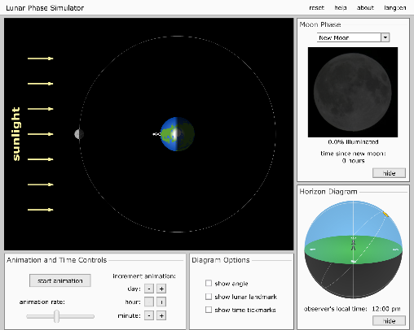 | University of Nebraska-Lincoln, Nebraska, United States  http://astro.unl.edu/naap/lps/animations/lps.swf  This interactive provides a detailed explanation of the phases of the moon. Users can easily adjust the time of day for the observer on the Earth and the position of the Moon. It also clearly shows how, when viewed from the Earth, the distance between the Moon and the Sun appears to change over time.

Instructions:
- Click “start animation” to start the Moon orbiting around the Earth and the Earth spinning on its own axis. The button changes to “pause animation” which can be pressed to stop the animation.
- The Moon Phase window shows how the Moon appears to an observer on the Earth.
- The Horizon Diagram window shows the position of the Moon relative to the Sun in the sky as seen by an observer on the Earth.
- Move the “animation rate” slide to increase/decrease the speed of the animation.
- Click the “-” and “+” buttons below “increment animation” to adjust the position of the Moon on the orbital path or the Earth on its axis. These can be manually adjusted by clicking and dragging directly on the Moon or the Earth.
- Additional options can be added to the interactive by ticking the checkboxes in the Diagram Options window.

Interactive 4 - Explaining the seasons
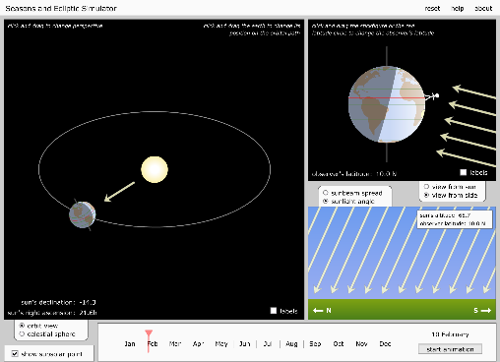 | University of Nebraska-Lincoln, Nebraska, United States  http://astro.unl.edu/naap/motion1/animations/seasons_ecliptic.swf  This interactive provides an animated model of the Earth orbiting the Sun, providing an excellent visualisation of changes in the angle and area of the sun’s light hitting the surface of the Earth. An excellent tool for exploring the concept of seasons.

Instructions:
- Click “start animation” button to start the Earth orbiting around the Sun. Observe how the area over which sunlight hits the Earth changes as the earth orbits the Sun (note: the rate at which the Earth spins on its own axis is extremely slow).
- Click and drag the Earth to change its position on the orbital path.
- Click and drag the orbital path up/down to adjust the plane of the orbit (providing a better view of a hemisphere of interest).
- Click and drag the stickfigure up/down to adjust the latitude of the observer on Earth.
- The “subsolar point” is the point on a planet where the sun’s rays are hitting the planet exactly perpendicular to its surface. It demonstrates the hottest day for that latitude.
- Various views are available for selection:
  - “orbit view” (default) - shows how the tilt of the Earth’s axis affects the amount of sunlight it receives on different parts of its surface.
  - “celestial sphere” - shows how the sun appears to moving across the sky according to the observer on Earth (the Earth’s axis is not tilted in the POV of the observer).
  - “sunlight angle” (default) - shows how the angle of the sunlight to the ground changes over time at a specific latitude.
  - “sunbeam spread” - shows how much the sunbeam spreads according to the observer on the Earth at a specific latitude over time.
  - “view from side” (default) - shows how the amount of sunlight on different parts of the Earth changes over a year, and why the seasons in the southern hemisphere are opposite to the northern hemisphere.
  - “view from sun” - shows how the tilt of the Earth’s axis changes the position of the subsolar point above and below the equator over the year.

Practical Activities

Activity 1 - Constellations
This activity allows students to draw their own constellation. It illustrates how different cultures around the world have seen different constellations in the sky in the same groups of stars.

Before or after this activity, students can research and discuss astronomy from different cultures, including Indigenous Australian astronomy.
Useful resources:
- ABC Science Australia’s First Astronomers
- Emu Dreaming - An Introduction to Australian Aboriginal Astronomy (book) by Ray and Cilla Norris
- Australian Backyard Astronomy (book) by Ragbir Bhathal

Equipment:
- Computer with access to internet OR print out of the group of stars pictured here
- Pencil
- Ruler

Method:
Virtual
- On the right is an image of a group of stars. Copy the image into a blank Google Doc.
- Click on the image and select “Edit”. This will open Google Drawing board.
- Select “line” and connect the stars to form a shape. Not all stars have to be connected by a line and it is okay to have more than one shape.

Tangible
- Print the image on the right.
- Using the pencil and the ruler, connect the stars to form a shape.

Suggested activities:
- Compare shapes drawn by various students:
  - How many types of shapes could be drawn using this set of stars?
  - Which shape was drawn most often? Why would this be the case?
- Write a story that features the shape and the story of why it is in the sky.
- Extension - open SDSS StarServer and draw a constellation from a chosen group of stars
  - Students will have to zoom out 5 times at least.
  - Zoom in and move the image (by clicking N, S, E or W) to centre the group of stars of choice and take a screenshot.
  - Repeat the method provided above for the screenshot.

Adapted from: http://cas.sdss.org/dr5/en/proj/kids/constellation/simple.asp

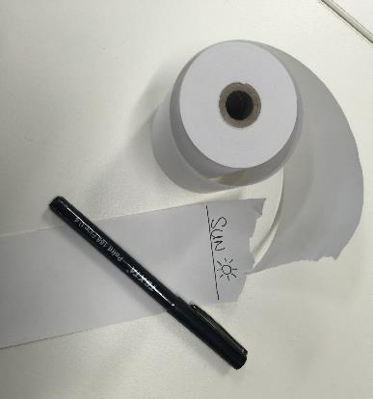
Activity 2 - Pocket Solar System
This activity uses a piece of long paper and a marker to demonstrate the distances between the planets in the Solar System. At the end, students can keep this Solar System model in their pocket/wallet/bag. This can be done as a guided activity, with the teacher reading out the instructions and asking students to suggest which planet name should be written at each position.

Equipment:
- Paper register roll
- Pen

Method:
- Ask students to recall the names of the planets and their order from the Sun.
- Measure out and tear off an arm span length of register paper.
- At the very end of the paper, write the word “SUN” and at the other end, write “PLUTO” (note that Pluto is classified as a dwarf planet).
- Fold the paper in half (so the SUN and PLUTO touch each other) and make a crease in the middle of the paper. Unfold the paper and write “URANUS” on the crease.
- Fold the paper back in half, and then fold it in half again. Unfold the paper completely - there should be two new creases, one between the SUN and URANUS and one between URANUS and PLUTO.
- Write “NEPTUNE” on the crease between URANUS and PLUTO.
- Write “SATURN” on the crease between the SUN and URANUS.
- Fold the SUN end of the paper to SATURN, unfold and write “JUPITER” on the crease.
- Fold the SUN end of the paper to JUPITER, unfold and write “ASTEROID BELT” on the crease.
- Fold the SUN to the ASTEROID BELT, unfold and write “MARS”
- Fold the SUN to MARS and then fold the doubled section in half again. When you unfold the paper you should see three new creases between the SUN and MARS at the positions where the innermost planets are located. Write “MERCURY” on the crease closest to SUN, then “VENUS”, and then “EARTH”.

Extension:
- Decorate the Solar System model with pictures and colours.
- Calculate and compare the relative distances of the planets from the Sun in this model with the actual distances.
- Devise a model for the relative sizes of the planets using everyday items (hint: use a Fitness ball or large beach ball for the Sun).

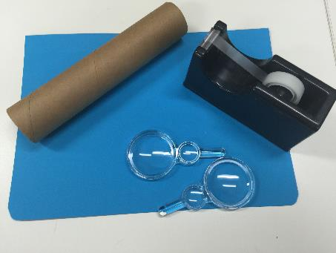
Activity 3 - Making a basic telescope
This activity uses simple, easily accessible materials to demonstrate how refracting telescopes work. Students then explore how to point a telescope at a distant object and focus the image.

Safety warning:
Do not use the lenses or telescope to look at the Sun!

Equipment:
- A4 piece of cardboard
- Empty paper towel roll
- Sticky tape
- 2 × convex lenses with different focal lengths (e.g. 150 mm and 500 mm double convex)

Method:
- Roll up the piece of cardboard the long way to form a tube that slides snugly inside the paper towel roll. Take the cardboard tube out of the paper towel roll and use sticky tape to hold the shape of the cardboard tube.
- Tape the edges of the lens with the longest focal length (objective lens) to the end of the paper towel roll.
- Tape the edges of the lens with the shortest focal length (eyepiece lens) to the end of the cardboard tube.
- Insert the empty end of the cardboard tube into the paper towel roll. Look through the eyepiece lens and point the objective lens at a distant object.
- Slide the tube in and out of the roll until the distant object comes into focus. The image should look upside-down and magnified.

Note: Depending on the focal lengths of the lenses, the cardboard tube and paper towel roll may need to be shorter or longer.

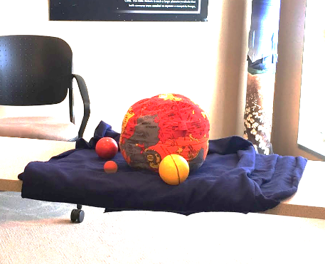
Activity 4 - Observing a strange new planet
This activity allows students to work in groups to develop their observational skills while demonstrating how the development of technologies allows astronomers to have a better understanding of the Solar System. Teachers will have to create a model planet PRIOR to this activity (be creative!).

Equipment:
- A model planet about the size of a basketball. This can be made from a basketball, a small beach ball, or a watermelon. Decorate the planet with coloured paper, paint, glitter, stickers, sweets or other objects. Consider adding scents to some areas. The more small details to be observed by students, the better!
- Table or a lab trolley
- Large cloth (e.g. towel)
- 4 × paper towel rolls with light blue cellophane attached at one end (“viewers”)
- 4 × push pin OR squares of masking tape

Method:
- Before students arrive, place the planet on the table/lab trolley at the back of the room and cover the planet with the large cloth to hide it.
- Divide the students into 4 groups and ask them to stand at the other end of the room. This area is the Mission Control.
- Provide each group with a viewer. Instruct group members to take turns to look at the planet through the viewer for 1 minute each. ALL group members waiting for their turn to use the viewer should have their backs to the planet. Uncover the planet to allow students to take turns viewing. After everyone has had a turn, cover the planet again with the cloth.
- Select two members from each group to stand about 3 metres away from the planet. All other students in the Mission Control should have their backs to the planet.
- Uncover the HALF of the planet that faces the students. The selected students move quickly past the planet in a straight line (no stops or pauses allowed). This models the “flyby” of a space probe. Cover the planet again with the cloth. Students share information with their group.
- Select two different members from each group to stand about 1 metre from the planet.
- Completely uncover the planet. The selected students circle steadily around the planet for 2 minutes, studying the features on the planet. This models the “orbiting” of a space probe. After 3 minutes, cover the planet with the cloth. Students share information with their group.
- Using the information collected from the viewing, flyby and orbiting activities, ask each group to plan which area of the planet they would like to land on.
- One group at a time places a pushpin or masking tape where they decided to land on the planet and group members observe the planet within a 2 cm radius around their chosen landing site.
- Within their groups, students compare the observations made by viewing, flyby, orbiting and landing. Students then compare their observations with those made by students in other groups.

Extension:
- Each group creates their own planet and then explores other groups’ planets.
- Each group creates a press-release to present their findings to the world.

Adapted from:
https://solarsystem.nasa.gov/docs/Strange_New_Planet.pdf

Useful Links
Below is a list of further links to supporting materials that may assist in teaching this topic.

- https://www.youtube.com/watch?v=L-Wtlev6suc
Crash Course Astronomy - Naked Eye Observations

- https://www.youtube.com/watch?v=wuhNZejHeBg
NASA Goddard - Lunar Eclipse Essentials

- https://www.youtube.com/watch?v=QXeEAQtC75g
History - The Universe: The Constellations

- https://www.youtube.com/watch?v=Y8ESZ-dQUbc
NASAeClips - Our World: Arecibo - the Largest Radio Telescope on Earth

- http://www.messenger-education.org/Interactives/ANIMATIONS/Planet_Mass_Comparison/PlanetMassComparison.swf
MESSENGER Education - Planet Mass Comparison

- http://astro.unl.edu/classaction/animations/telescopes/telescope10.swf
University of Nebraska-Lincoln - Telescopes

- http://faculty.buffalostate.edu/sabatojs/courses/GES131/figures/ReasonForSeasons.swf
Pearson Education - Much more than distance - How Earth’s tilted axis causes the Seasons

- http://sciencenetlinks.com/interactives/moon/moon_challenge/moon_challenge.swf
Science NetLinks - Lunar Cycle Challenge

- http://zenpencils.com/comic/52-phil-plait-welcome-to-science/
Phil Plait - Welcome to Science Comic

- http://www.lpi.usra.edu/education/workshops/phasesSeasons/OreoPhases.pdf
Lunar and Planetary Institute - Oreo Phases

- http://www.jpl.nasa.gov/edu/teach/activity/moon-phases/
Jet Propulsion Laboratory - Moon Phases

