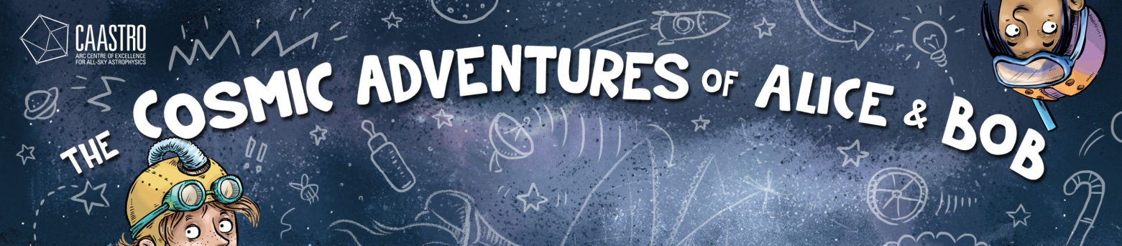

Teaching notes
The Cosmic Adventures of Alice & Bob is a fully-illustrated comic book that was produced by CAASTRO, the Australian Research Council Centre of Excellence for All-sky Astrophysics, to communicate ideas about science research, innovation, and astronomy to primary school children. The book can be read on a number of different levels and the classroom ideas presented here can be adapted to the various interests and abilities of students. The book is most suitable for children in Years 3 to 6, but this could be extended to Year 2 and Years 7 and 8 depending on individual students.

The Cosmic Adventures of Alice & Bob
Author: Cristy Burne
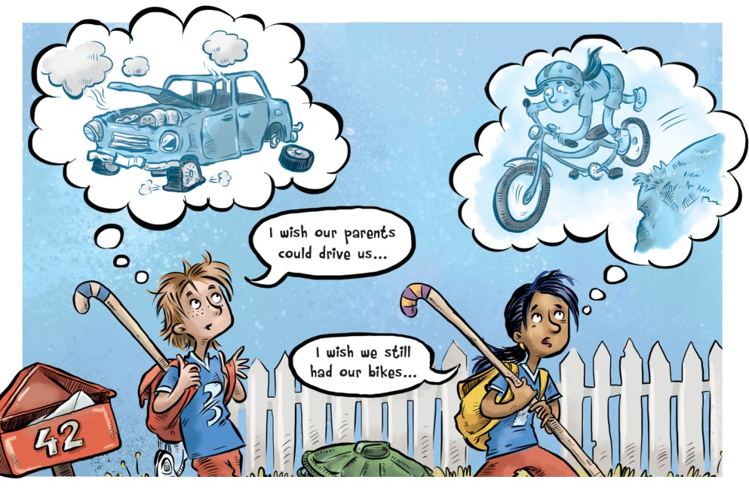
Illustrator: Aśka
CAASTRO contributors:
Dr Wiebke Ebeling (editor-in-chief)
Jenny Lynch (co-editor)
Dr Christian Wolf (co-editor)
ISBN: 978-0-646-96056-2
Audience: Years 3 to 6
Publication date: March 2017

Themes
- Innovation and Creativity
- Invention
- Design and Technology
- Science and Engineering
- History
- Astronomy

About the book
A comic book celebrating scientific dedication, daring and discovery…
Ever wanted to find the answers to BIG questions? Or dreamed of inventing the Next Big Thing?
The Universe is an amazing place, and we’re only beginning to understand it. There’s still so much to be discovered…
- Join Alice and Bob on their ambitious journey to the hockey finals
- Uncover true stories of scientific failure, fluke and fame
- Find the everyday inventions that began with space research
- Meet the world’s next-generation telescopes, jump on board with Citizen Science, and tackle the big questions with CAASTRO: Australia’s keen team of all-sky astronomers.

About the Author and Illustrator
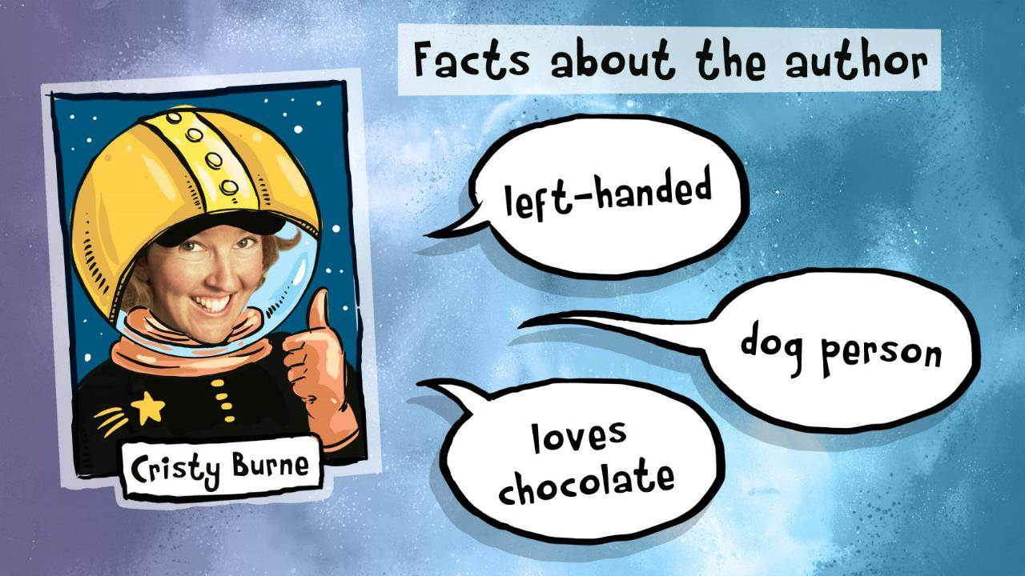

Cristy Burne is a children’s author and science writer. She is a past editor of CSIRO’s Scientriffic magazine for children and a regular contributor to The Helix and Crinkling News for children and teenagers. Cristy has worked as a travelling performer with the Shell Questacon Science Circus, and a science writer at CERN in Switzerland, Fermilab in the US and Scitech in Perth. She has a Bachelor of Science in biotechnology, a Graduate Diploma in Science Communication, and a Masters in Professional Communication. She loves making, reading and talking about books.
www.cristyburne.com

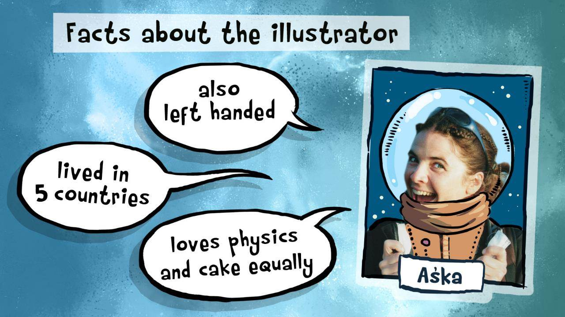

Aśka is an illustrator, scientist and adventurer. She has an Arts Degree from Curtin University in Perth, and an Honours Degree in Quantum Physics from the Australian National University in Canberra. Aśka has over ten years’ experience in children’s illustration and book development, as well as being a science communicator at Scitech in Perth. She is endlessly curious about the wonderfully rich world around us, and loves to explore it through her characters and illustrations.
www.askaillustration.com

Australian Curriculum Links
Year 3 to 6
English, Science, Mathematics, Technologies: Design and Technologies, The Arts: Visual Arts

Classroom ideas

Before reading:
- Look at the book’s cover. What do you think this book will be about?
- Do you think it will be fiction or non-fiction?
- Now read the blurb on the back cover. Does this change your ideas?
- Do you know any famous scientists? What do you know about how they lived and worked, and the stories behind their inventions?

After reading:

English
- Most of the stories in this book are non-fiction, but one is entirely fictional. Which stories are true? Which story is imaginary? How does the artwork indicate this to the reader?
- What is the problem that drives Alice and Bob’s story? How do they solve that problem? Can you think of other ways you might solve that problem?
- Alice and Bob are portrayed as ordinary kids. Why do you think that is important to the story? How would the message of the story change if Alice and Bob were child geniuses?
- Imagine you could invent a technology that could change the world. What would it be? To invent it, what challenges would you need to overcome?
- Alice says: “This sort of thing only happens once in a lifetime!” Bob replies: “Or maybe infinite times over parallel lifetimes…” Do you believe in parallel universes? Write a story where you meet yourself in a parallel universe.
- Many of the true stories in this book include some sort of failure as part of the discovery process. Have you ever failed at something and had to try again? How does that feel? How do you think scientists find the courage to keep trying?
- While trying to make their scooter, Alice and Bob discover something they didn’t expect. Can you think of other examples where someone has tried hard for one thing and discovered something else?
- Jocelyn Bell missed out on a Nobel Prize for her discovery of pulsars, and her professor, Tony Hewish was awarded the prize instead. Why do you think this happened? Do you think that is fair? Do you think it would still happen today?
- Albert Einstein is one of the world’s most famous scientists. He never learned to swim and he never learned to drive, but his scientific theories changed the world, earning him a Nobel Prize. He famously said, “I have no special talents. I am only passionately curious.” Do you think talent is more important than curiosity? Do you believe ordinary people can achieve extraordinary things, or are these things mostly done by geniuses?

Science
- Alice and Bob’s successful scooter uses a poop engine for power. Do you think this might actually work? Where has poop been used to create energy before?
- This book lists many everyday technologies that were first used in space science. Other examples of technology originally invented for astronomy include: the microchips for modern computing; the technology for X-rays, CAT scans, and ultrasounds; high-performance solar cells; high-tech coffee machines; insulating paint; artificial limbs; intelligent ovens; fibreglass guitars; and even invisible dental braces. Choose one of these examples and find out more about it.
- The Square Kilometre Array (SKA) will be the world’s most powerful radio telescope. Where will it be located? Astronomers will use the SKA to peer deep into the Universe. Use the internet to research the SKA to find out how astronomers will use it and how much astronomy data it will produce.
- Quotes that have been attributed to famous scientists appear in the book, either as direct quotes or reworded (paraphrased). Can you find some of the following quotes in the text? Choose your favourite quote and find out more about the famous scientist who first said it.
Dr Albert Einstein
- ‘Creativity is contagious – pass it on’
- ‘I have no special talents. I am only passionately curious.’
- ‘Curiosity has its own reason for existing.’
- ‘It's not that I'm so smart, it's just that I stay with problems longer.’
- ‘We cannot solve our problems with the same thinking we used when we created them.’
- ‘The important thing is not to stop questioning.’
- ‘If we knew what we were doing, it would not be called research.’
- ‘Anyone who has never made a mistake has never tried anything new.’
Dr Thomas Alva Edison
- ‘Genius is one percent inspiration, ninety-nine percent perspiration.’
- ‘I have not failed. I've just found 10,000 ways that won't work.’
Sir Howard Florey
- ‘This sort of thing only happens once in a lifetime!’
- ‘One sometimes finds what one is not looking for.’

Maths
- Numbers are used through the images and text, but they’re not random numbers. Can you match these numbers with the facts?
- 18 March, 6:30pm = The launch date and time for this book
- 268 = Number of megapixels in SkyMapper’s camera
- 9.8 = Acceleration due to gravity, measured in metres per second squared (ms⁻²)
- 161 km/h in 8 seconds = NASA’s two million kilogram Space Shuttle reached a speed of 161km/h just eight seconds after take off
- 42 = The answer to the ultimate question of life, the universe and everything (according to the science fiction series The Hitchhiker’s Guide to the Galaxy, by Douglas Adams)

Design and Technologies
- Alice and Bob use some recycling to create their scooter. Can you design something different with the objects they used? Can you draw a design for a creation made from recycled objects you find around your own house? Two activity sheets are provided at the end of these notes (one featuring Alice and the other featuring Bob).
- Alice and Bob create a “frequency-division multi-plexer,” a “quantum-gravity modulator,” and a “trans-finite-in-findi-bulator.” What do you think these pieces of equipment do? Select one piece of equipment, draw a diagram of the equipment, label your design, and describe what it does, pointing out the special features that make it work.

Visual Art
- Albert Einstein famously said, “God does not play dice with the universe.” The picture you see when you first open the book is designed to show the evolution of the Universe as a board game, with three dice in the corners. Why do you think it was designed in this way?
- Research the story of an invention that you use every day, then draw a one-page comic strip to tell the story of how it was invented.
- Alice and Bob end up arriving early for their hockey game. How early do you think they are? How does the artwork show us this?
- Every word and image must earn its place in a comic book by conveying information. See if you can find references to the following in the text:
  - ‘Ahoy’: Alexander Graham Bell, inventor of the telephone, wanted to use ‘Ahoy’ rather than ‘Hello’ when answering a telephone call.
  - ‘Alice and Bob’: Alice and Bob are the names of two fictitious people who are often used by computer scientists, physicist, and mathematicians when explaining problems. For example, Alice (person A) sends a message to Bob (person B) across a computer network.
  - ‘Aquamarine’: Research from 2002 suggested that the average colour of the Universe was turquoise or aquamarine. However, the same researchers found a mistake in their measurements and recalculated the colour of the Universe to be ‘Cosmic Latte’ or beige.
  - ‘Butterfly Nebula’: The Butterfly Nebula is a dying star that is pumping out massive, super-heated gas clouds that look like butterfly wings.
  - ‘SDA’: Hidden on the scooter is an acknowledgement of Scott Douglas Altman, whose nickname was “Scooter.” He was an engineer, test pilot and NASA astronaut.

Internet links
- CAASTRO: www.caastro.org
- CAASTRO Education & Outreach: http://caastro.org/education-and-outreach
- CAASTRO in the Classroom, an outreach program for schools, offering free online resources, live streaming events and video conferencing presentations: www.caastro.org/citc
- SkyMapper: http://skymapper.anu.edu.au/
- Murchison Widefield Array: http://www.mwatelescope.org/
- Square Kilometre Array: https://skatelescope.org/
- Radio Galaxy Zoo: https://radio.galaxyzoo.org/
- Snapshot Supernova: https://www.zooniverse.org/projects/zooniverse/snapshot-supernova/
- Galaxy Explorer: https://www.galaxyexplorer.net.au/
- NASA spin-off technologies: https://spinoff.nasa.gov/
