Identifying supernovae

Introduction
In these activities you will use real images from an Australian telescope to find supernovae. A supernova (plural supernovae) is a very rare catastrophic event that occurs at the end of the life of a star. It appears as very bright object in the sky, like the appearance of a new star, and it can shine brighter than all the stars in a galaxy, before fading over weeks or months. Most of the heavy elements in the universe have been produced by the explosive nuclear fusion of a supernova. Astronomers have made beautiful images of supernova remnants, like the one shown here of the expanding clouds of material left behind by a supernova. | 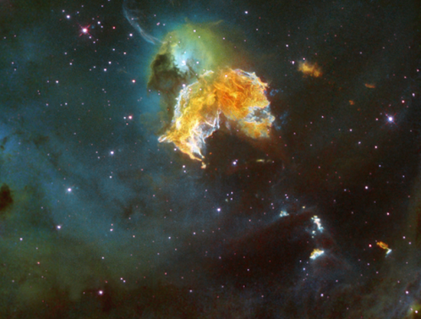  Image credit: ESA/Hubble & NASA, CC BY 3.0, https://commons.wikimedia.org/w/index.php?curid=19319493

In Coonabarabran, a rural location in New South Wales, astronomers are using the SkyMapper telescope to look for supernovae and other astronomical events. The SkyMapper telescope is an automated, optical telescope that will scan and take pictures of the whole southern sky over 5 years. It also takes pictures of a large area of sky every few days, creating a time lapse movie that allows astronomers to look for changes that occur in the Universe, including the appearance of supernovae. | 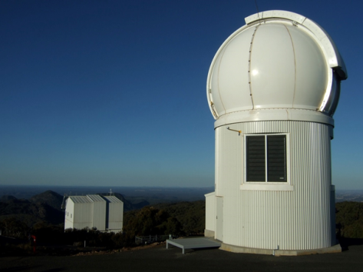Image credit: Iridia (Own work) [CC BY-SA 3.0 (http://creativecommons.org/licenses/by-sa/3.0)], via Wikimedia Commons

Activities
There are two methods provided here for identifying the location of the supernovae using pairs of images.

Simple version
This version takes about 20-30 minutes to complete. It uses GIFPAL, an online application that creates animated .gif files using uploaded images and/or photos taken with a webcam. Students will be creating a .gif file to compare two images taken of the same area of the night sky. Using a .gif to flip between the ‘before’ and ‘after’ images can help students to look for changes in the area of the sky and spot the locations of supernovae in the ‘after’ images.

Method
- Download a set of images from the following folder on Google Drive. Right click on each image and select ‘Save Image As’. There are 5 pairs of images and each pair is the same area of the night sky, taken at different times. The ‘after’ images each have a supernova; the ‘before’ images do not.

- Go to GIFPAL.

- Click “Get started now” button then select “Start without Webcam”.

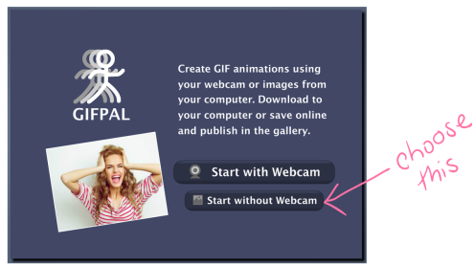

- Click the “Select Image” button and then “Add Images” to add sn1before.png to the Images Library. Click on the image and then the “Select” button.

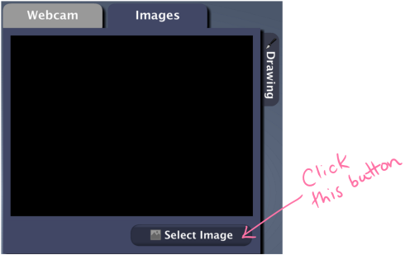

- Click the camera icon () to place sn1before.png in the frame. The image also appears on the .gif preview window.

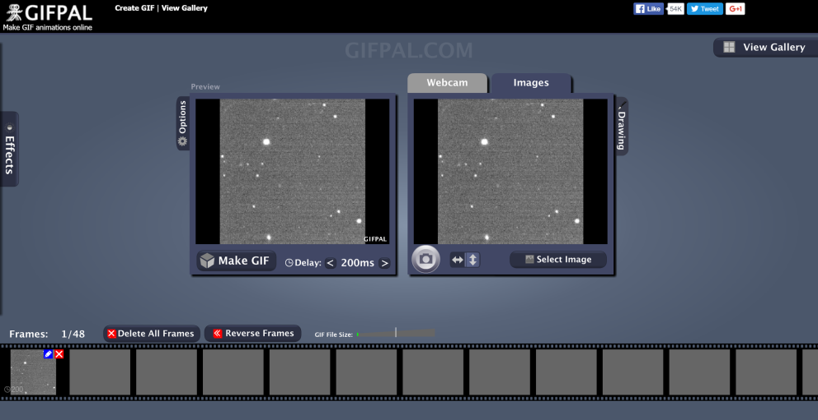

- Repeat steps 3 & 4 for sn1after.png

- Adjust the delay in switching between two images by clicking the arrows: “>” for an increase in the delay and “<” for decrease in the delay.

- Click on the “Make GIF” button and then “Download GIF” to save the file to the computer.

- Using your GIF, can you see any differences between the ‘before’ image and ‘after’ image? The supernova in the ‘after’ image will appear as a white spot.

- Repeat Steps 1-7 for the remaining supernovae.

Advanced version
This version takes about 60 minutes to complete. It uses PIXLR EDITOR, an online application similar to Adobe Photoshop. Students will perform a simulated image subtraction process, similar to the process used by astronomers to identify supernovae. PIXLR EDITOR allows students to adjust the ‘before’ and ‘after’ images to remove background noise and then overlay the ‘after’ image on top of the ‘before’ image. Students will then change the transparency of the ‘after’ image to compare matching pixels with the ‘before’ image. The unmatched pixels will look black, allowing students to identify the supernova clearly.

Method
- Download a set of images from the following folder on Google Drive. Right click on each image and select ‘Save Image As’. There are 5 pairs of images and each pair is the same area of the night sky, taken at different times. The ‘after’ images each have a supernova; the ‘before’ images do not.

- Go to PIXLR EDITOR.

- Select “OPEN IMAGE FROM COMPUTER” and open sn1before.png

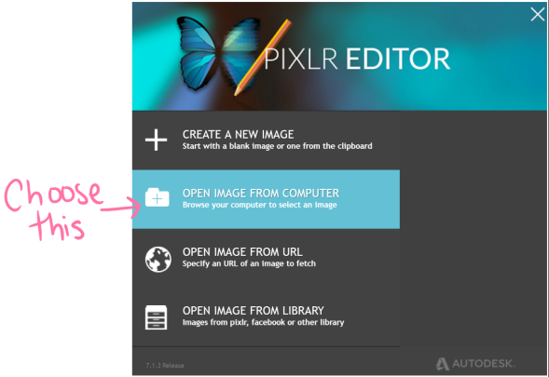

(continued on page 5)

- Double click the lock icon () next to Background layer in the Layers window. This allows the layer to be editable. It will be automatically renamed as Layer 0.

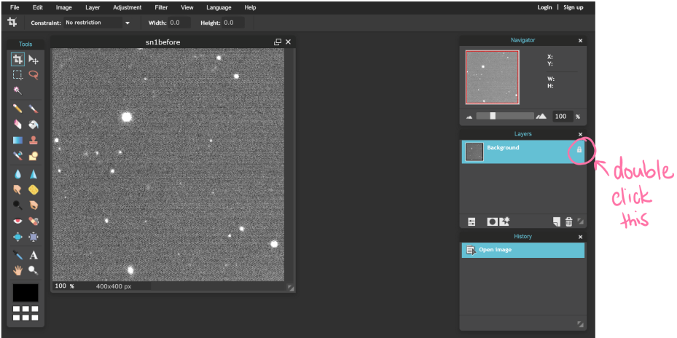

- Go to “Adjustment” and select “Brightness and Contrast…”. The Brightness and Contrast window will pop open with TWO adjustable slides. Move the slides to reduce the background noise (fuzzy background) of the image in Layer 0 and make the stars and galaxies easier to see. Your image should now have a dark background with bright white stars and galaxies. Click “OK” to save changes.

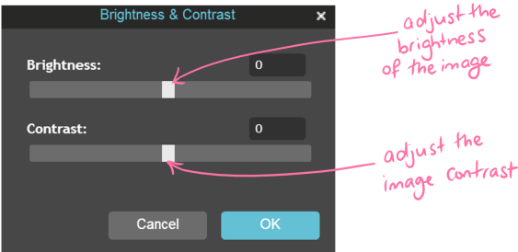
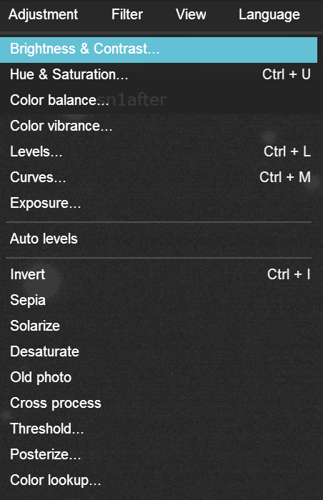

- Go to “Layer” and select “Open image as layer”. Open sn1after.png. There will be TWO layers in the Layers window: Layer 0 and Layer 1.

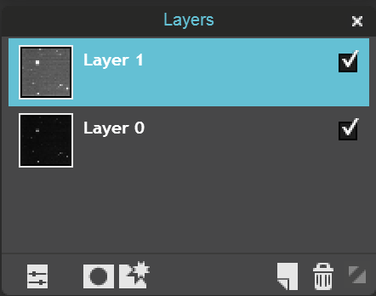
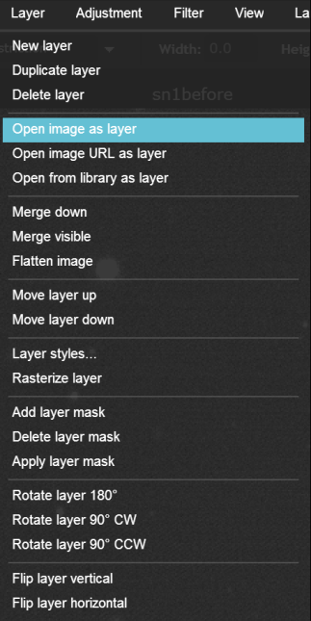

- Select Layer 1 and repeat Step 4 for Layer 1.

- Select Layer 1 then go to “Adjustment” and select “Invert”. This will invert the whites and blacks in the Layer 1 image.
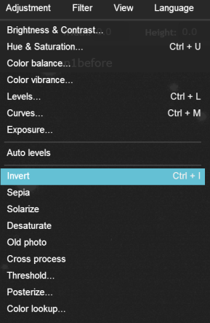
- In this step, you will make Layer 1 translucent so you will be able to see through it to Layer 0 and compare the images. With Layer 1 still selected, click “Toggle layer settings” icon () in the “Layers” window. Adjust the Opacity slider until most objects turn grey-white (approximately 50% opacity with 10% error margin).

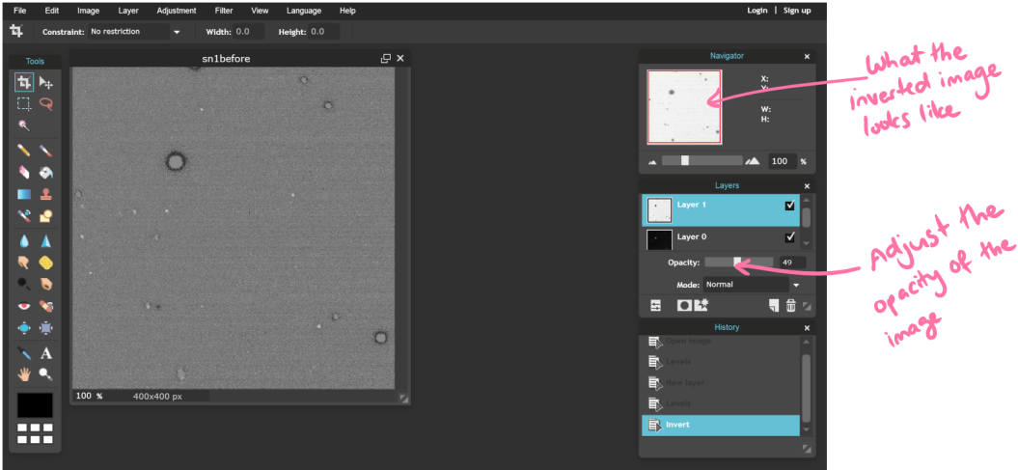

- Now you should be able to see the location of the supernova. Look for a clear black spot and use the following method to mark the location. Click the “Drawing tool” icon (), then click the “Ellipse tool” icon (). Uncheck the “Fill shape” box and change the colour of the ellipse to anything BUT black (red was chosen for the example) by clicking the “Set main color” box. Draw an ellipse around the black spot to mark the location of the supernova.
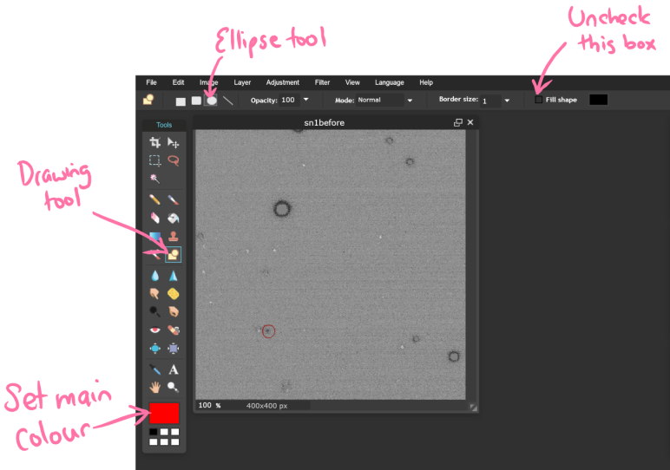
- Go to “File” the select “Save…” to save the image. Change the name of file to sn1 and set the file format to “PNG”. Click “OK”.
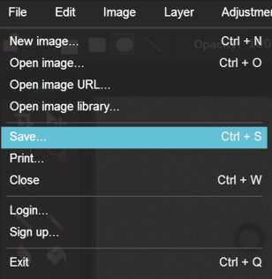
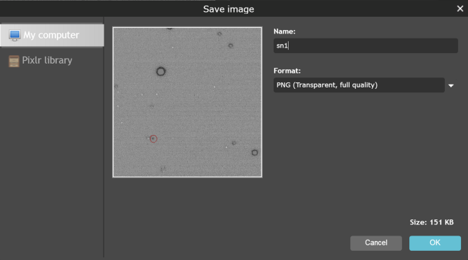

- Repeat steps 1 - 9 for the other supernova images.

Looking at your results
You might have found all of the supernovae in the pairs of images, but you also might have found some objects that look like they could be supernovae, but really weren’t. While this activity gives you an idea of the process used by astronomers to subtract images, it is an approximation. The two images in each pair were taken under different atmospheric conditions, such as wind and air temperature. This will affect how objects appear in the image because the light from the stars, galaxies and supernovae had to travel through the Earth’s atmosphere to reach the telescope. Astronomers use specialised computer programs that can match the brightness of objects that do not change so these objects can be accurately subtracted. This allows them to more reliably detect any changing objects, such as supernovae.

