Gravity and Orbits

These worksheets are designed to be read by students before viewing a CAASTRO in the Classroom video conferencing session. The ‘Pre-visit activities’ can be completed prior to the conference session and the ‘Post activities’ are provided as suggestions for follow-up activities.

Table of contents

Table of contents
Pre-visit Activities
Glossary
Revision Videos
Post-visit Activities
Online Interactives
Interactive 1 - Planetary orbit simulator
Interactive 2 - Gravitational field and mass
Interactive 3 - Uniform circular motion
Interactive 4 - Gravity launch
Practical Activities
Activity 1 - Measuring Earth’s acceleration due to gravity
Activity 2 - Centripetal force
Activity 3 - Eccentricity of ellipses
Useful Links

Pre-visit Activities

Glossary
The following terms may be cited during the video conferencing session. If students need assistance, refer them to the ‘Revision Videos’ section or any Physics textbook.

Terms | Definition
Gravity
Mass (m)
Weight (F_{g})
Universal gravitational constant (G)
Gravitational potential energy (E_{p})
Orbit
Orbital period (T)
Ellipse
Kinetic energy (E_{k})
Work (W)
Orbital decay
Gravitational field
Uniform circular motion
Orbital velocity

Glossary with answers

Terms | Definition
Gravity | The force of attraction between two physical bodies that have mass.
Mass (m) | A property of an object that is dependent only on the amount of matter in the object.
Weight (F_{g}) | A force on an object due to the effect of gravity: $F_{g}=mg$
Universal gravitational constant (G) | A physical constant used in calculations of the gravitational force between two objects. G $=6.67×{10}^{-11}$ Nm²kg⁻².
Gravitational potential energy (E_{p}) | The work done on an object to move it from an infinite distance to a point within a gravitational field: $E_{p}=\frac{Gm_{1}m_{2}}{r}$
Orbit | The elliptical path of an object moving around another object under the force of gravity.
Orbital period (T) | The time taken for an object to make one complete orbit around another object.
Ellipse | A regular oval shape that is traced by a point moving in a plane so that the sum of its distances from two foci is constant.
Kinetic energy (E_{k}) | The energy of an object due to motion. $E_{k}=\frac{1}{2}mv^{2}$
Work (W) | An action that involves applying force on an object resulting in displacement of the object. The net work done on an object is equal to the total change in energy. $W=Fs$
Orbital decay | A process of gradual decrease in the radius of an orbit due to loss of energy of the orbiting object.
Gravitational field | A region of influencein which objects experience a force of attraction due to gravity.
Uniform circular motion | The motion of an object travelling at a constant speed in a circular path.
Orbital velocity | The minimum velocity at which a body must move to maintain a given orbit.

Revision Videos
The following is a list of useful revision videos. Students can:
- Take notes on the videos for themselves; OR
- Review one or more of the videos for their classmates as a homework exercise, giving each video a rating and commenting on how well the video communicated the science content.

- Gravity, orbits, and escape velocity:
https://www.youtube.com/watch?v=TRAbZxQHlVw
CrashCourse - The Gravity of the Situation: Crash Course Astronomy #7

- Orbital velocity and gravity:
https://www.youtube.com/watch?v=iQOHRKKNNLQ
Veritasium - Why are astronauts weightless?

- Newton’s law of universal gravitation:
https://www.youtube.com/watch?v=SN1Q5ru2fI0
Veritasium - Calculating Gravitational Attraction

- Kepler’s first law explained:
https://www.youtube.com/watch?v=qDHnWptz5Jo
Socratica - Kepler’s First Law of Motion - Elliptical Orbits (Astronomy)

- Kepler’s second law explained:
https://www.youtube.com/watch?v=qd3dIGJqRDU
Socratica - Kepler’s Second Law of Motion (Astronomy)

- Kepler’s third law explained using centripetal force:
https://www.youtube.com/watch?v=KbXVpdlmYZo
Socratica - Kepler’s Third Law of Motion (Astronomy)

Post-visit Activities

Online Interactives

Interactive 1 - Planetary orbit simulator
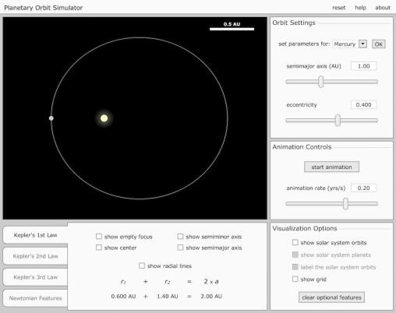 | University of Nebraska-Lincoln, Nebraska, United States  http://astro.unl.edu/naap/pos/animations/kepler.swf  This interactive provides a detailed demonstration of Kepler’s three laws of motion. Users can manipulate various aspects of the orbit of a planet such as the size of the semimajor axis and its eccentricity, to see how this affects the orbital period, and the velocity and the acceleration of the planet.

Instructions:
- Click “start animation” button in the Animation Controls window to start the planet orbiting around the Sun. The button changes to “pause animation” which can be pressed to stop the animation.
- Move the “animation rate” slider to increase/decrease the speed of planet orbiting the Sun.
- To view orbits of a specific planet in the Solar System, select the planet from the “set the parameters for” dropdown menu in the Orbit Settings window then click “OK”.
- Move the “semimajor axis (AU)” slider to increase/decrease the overall size of the orbit.
- Move the “eccentricity” slider to adjust how much the orbit deviates from circular shape.
- Various views are available for selection in Visualization Options window:
  - “show solar system orbits” - shows all the orbits of the planets in the solar system in orange in proper scale
  - “show solar system planets” - shows the planets moving along the orbits (this option is only available AFTER the solar system orbits are visible)
  - “label the solar system orbits” - labels which orbit belongs to which planet (this option is only available AFTER the solar system orbits are visible)
  - “show grid” - shows the grid-lines in space with axes centering from the Sun.
- Kepler’s 1st Law tab provide specialised views to help visualise the law (default). These views remain when moving to other tabs:
  - “show empty focus” - shows the other focus of the orbit
  - “show center” - shows the midpoint between the two foci of the orbit
  - “show semiminor axis” - shows the semiminor axis of the orbit
  - “show semimajor axis” - show the semimajor axis of the orbit
  - “show radial lines” - shows the lines joining two foci to the planet.
- Kepler’s 2nd Law tab provides adjustments to visualise the areas swept over the same time duration
  - Clicking the “start sweeping” button sweeps out an area within the orbit over a specific time duration, from the position where the planet was when the button is pressed. A new sweep area is formed every time the button is clicked.
  - Clicking the “erase sweeps” button removes all the sweep areas.
  - Move the the “adjust size” slider to increase/decrease the time duration of each sweep.
  - Select “sweep continuously” to have another area swept straight after the other until the planet completes the orbit.
  - Select “use sound effect” for sounds made for every area swept
- Kepler’s 3rd Law tab displays the relationship between the period and the semimajor axis as a graph.
  - Select “linear” (default) or “logarithmic” to change the scale of the graph.
- Newtonian Features tab shows how the velocity and the acceleration of the planet change as it orbits around the Sun.
  - Click “vector” to see the magnitude and the direction of velocity and acceleration of the planet.
  - Click “lines” to see the tangent of the orbit through the planet and the line representing the distance between the Sun and the planet.

Interactive 2 - Gravitational field and mass
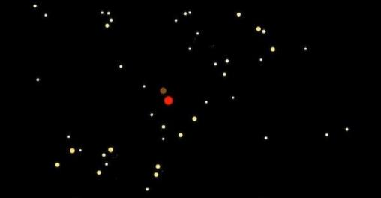 | http://dagobah.net/flash/space_gravity.swf  This interactive allows the users to visualise how gravitational field around various sized objects affect objects around them. Users can determine the mass, position, velocity of the objects and the total number of objects to observe how they interact with each other.
Instructions:
- Click on the screen to create an object, click and drag to give the object velocity (longer the drag before release, greater the object velocity)
- The following buttons determine the size of the object you create:
  - Tiny = 1 unit of mass
  - Small = 1000 units of mass
  - Medium = 10 000 units of mass
  - Large = 100 000 units of mass
  - Huge = 1 000 000 units of mass
  - OMFG = 10 000 000 units of mass
It is also possible to specify the mass by entering a value in the box next to “Mass:”
- To move the view around (so you can see particles that have moved out of the screen) hold ctrl while clicking and dragging the screen.
- To delete a specific object, shift click the object.
- Click “Clear” to clear everything on the screen and start again.
- Select “Paths” to show a trail of the pathway of each particle.
- “Generate a proto disk (slow start)” button generates a specific number of particles with various sizes, modelling the formation of stars and planets due to gravitational interaction.
- The number next to “particles:" tells you how many individual objects exist.

Interactive 3 - Uniform circular motion
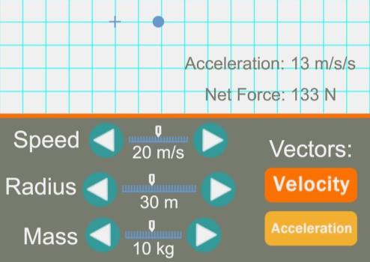 | Tom Henderson, The Physics Classroom, Illinois, United States  http://www.physicsclassroom.com/PhysicsClassroom/media/interactive/CircularMotion/index.html  This extremely simple interactive demonstrates the relationship between the centripetal force on an object and the mass, velocity and radius of the object. Users can use it to understand the centripetal force equation.

Instructions:
- Click the “start” button to move the object into uniform circular motion around the cross. Its pathway will be marked with small blue dots.
- To adjust the speed, radius or mass of the object, click on the left and/or right arrows on the scales corresponding to “Speed”, “Radius” & “Mass”.
- Click the “Velocity” and “Acceleration” button to see the vector arrows representing the velocity and acceleration respectively on the object.
- Click “reset” to start again.

Interactive 4 - Gravity launch
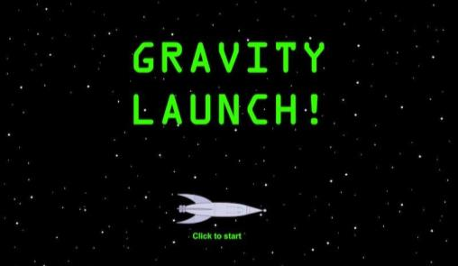 | http://sciencenetlinks.com/interactives/Gravity%20Launch2.6.swf  This fun interactive demonstrates how the forces of gravity and thrust can be used to direct a rocket to a space station. The user must successfully select the thrust and angle of the rocket launch to achieve the correct escape velocity and trajectory to reach the target.

Instructions:
- Aim of this game is to dock the spaceship into one or more space stations by adjusting the spaceship’s thrust and angle only ONCE. There are FIVE different space missions.
- Prior to launching the space ship:
  - adjust the spaceship’s thrust using the lever located on the THRUST panel.
  - adjust the angle of the launch using the dial located on the ANGLE panel.
- Press the red button on the LAUNCH panel to launch the spaceship into space.

Practical Activities

Activity 1 - Measuring Earth’s acceleration due to gravity
This is a classic activity to determine the acceleration due to gravity using a pendulum.
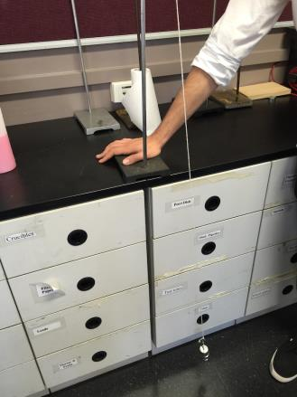
Background information:
The period of a simple pendulum can be found using the formula:

$$T=2π\sqrt{\frac{l}{g}}$$

$T$ = period of the pendulum
$l$ = length of the string
$g$ = acceleration due to gravity

Equipment:
- Retort stand
- Bosshead
- Clamp
- 1 m of string
- 50 g mass carrier
- Stopwatch
- 1 m ruler

Method:
- Set up the apparatus as shown in the picture (right) - the other end of the string is attached to the clamp on the retort stand.
- Using the ruler, carefully measure the length of the pendulum from the knot at the top to the base of the mass carrier. Record the measurement.
- Swing the pendulum gently (lifting the weight to an angle less than 30°). Use the stopwatch to measure the time taken for the pendulum to complete 10 complete (back-and-forth) swings.
- Repeat steps 1-3 FIVE times.
- Tabulate your results and calculate the period of the pendulum.
- Use your results to calculate g, the acceleration due to gravity. Include errors in your answer.

Extension:
- How could you improve the accuracy of this experiment? As an inquiry-based activity, students form an hypothesis and design experiments to test their hypothesis.

Activity 2 - Centripetal force
This activity explores the effect changing radius of circular motion has on the centripetal force.
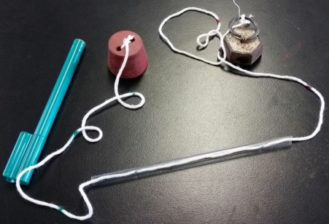
Equipment:
- Rubber stopper
- Small glass tube
- 1.5 m long string
- 1 kg mass
- Marker pen
- 1 m ruler

Method:
- Measure the mass of the rubber cork.
- Set up the apparatus as shown in the picture: push the string through the glass tube, tie one end of the string to the cork and the other end of the string to the 1kg mass.
- Measure 10 cm from the centre of rubber stopper and mark the position on the string with the marker pen. Make marks at 10 cm intervals from first mark and repeat this until the last mark is at 50 cm from the centre of the stopper.
- Hold the glass tube such that the stopper is placed on top of the glass tube and the mass is hanging on the other end of the string.
- Spin the cork so that it moves in a circular path. Adjust the motion of the cork so that the first 10 cm mark on the string touches the edge of the glass (the radius = 10 cm)
- Record the time for the cork to complete 10 revolutions at a constant speed (as constant as you can make it). Record the results in the results table.
- Repeat steps 4 - 6 for radii of 0.2 m, 0.3 m, 0.4 m, and 0.5 m.

Results:

Radius (m) | Time taken for 10 revolutions (s) | Period (s) | Orbital velocity (ms⁻¹) | Centripetal force (F_{c})
0.1
0.2
0.3
0.4
0.5

Extension:
- Calculate the weight force of the mass and compare that to the centripetal force calculated.
- Use the results to see if Kepler’s Third Law (for circular orbits) works.

Activity 3 - Eccentricity of ellipses
This is a simple investigation for students to learn about the relationship between the eccentricity of an ellipse and the distance between the two foci. It helps them to see a circle is a special type of ellipse (cross-curricular link to locus in Mathematics).
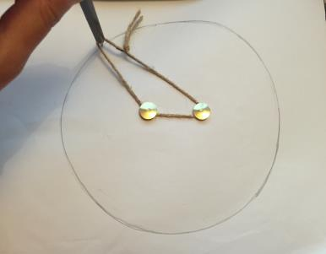
Equipment:
- 15 cm - 30 cm piece of string
- Playdough (or a long rubber)
- A4 paper
- 2 × thumbtacks
- Pencil
- 30 cm ruler

Method:
- Tie the two ends of the string together to make a loop. Measure the length of the loop using the ruler.
- Place the playdough flat behind the paper and push a thumbtack through the middle of the paper into the playdough. Leave a small gap between the paper and the flat top of the thumbtack.
- Place the string around the thumbtack and put the tip of the pencil inside the loop. Pull the string taught and use the pencil to trace a circle, pulling against the string to keep it tight.
- Remove the thumbtack. Use the ruler and pencil to mark two points on the paper that are 1 cm apart, with the original thumbtack hole at their midpoint. Push a thumbtack through the paper at each point.
- Repeat Step 3, but this time the string will be wrapped around both thumbtacks.
- Repeat Step 4 with thumbtacks at 2 cm, 3 cm, 4 cm, 5 cm apart. Compare the shapes that are traced.

Extension:
- Try re-creating the orbits of the solar system using the following information:
  - Pin separation = $\frac{es}{1-e}$ where $s=$2 × length of string loop

Planet | Eccentricity (e)
Mercury | 0.21
Venus | 0.01
Earth | 0.02
Mars | 0.09
Jupiter | 0.05
Saturn | 0.06
Uranus | 0.05
Neptune | 0.01

Useful Links
Below is a list of further links to supporting materials that may assist in teaching this topic.

- https://www.youtube.com/watch?v=u7KpH9_I2Dw
Veritasium - Gravity (Scientific Version of John Mayer's Gravity)

- https://www.youtube.com/watch?v=mezkHBPLZ4A
Veritasium - What Is Gravity? (A good conversation starter at the beginning of a lesson)

- https://www.youtube.com/watch?v=Yjg6mRFzZzE
Shondon - Hilarious G-Force training

- http://www.testtubegames.com/gravity.html
TestTubeGames - Gravity simulator

- http://goo.gl/PSDoXp
McGrawHill Education - Solar System Builder

- http://goo.gl/ZXQ2rL
McGrawHill Education - Kepler’s Second Law

- http://interactagram.com/physics/kinamatics/circularMotion/circularMotion.swf
Interactagram.com - Uniform Circular Motion (and its relations to Simple Harmonic Motion)

- http://channel.nationalgeographic.com/channel/content/known-universe/index.html
National Geographic - Solar System Builder (building a planetary system)

